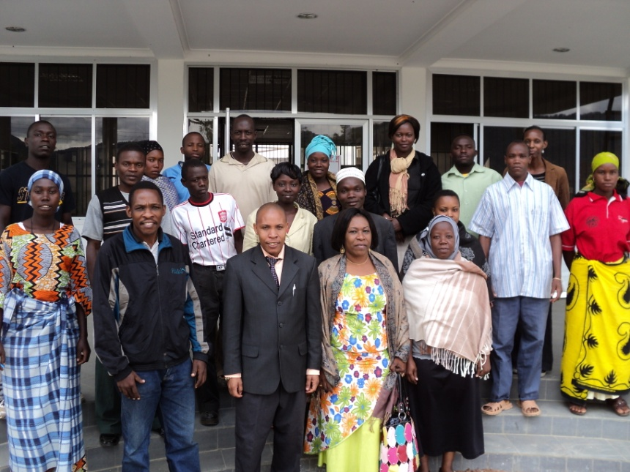
Hon. Betrice Shelukindo in group photo with Kilindi youth parliament during election Kilindi Bunge leaders

