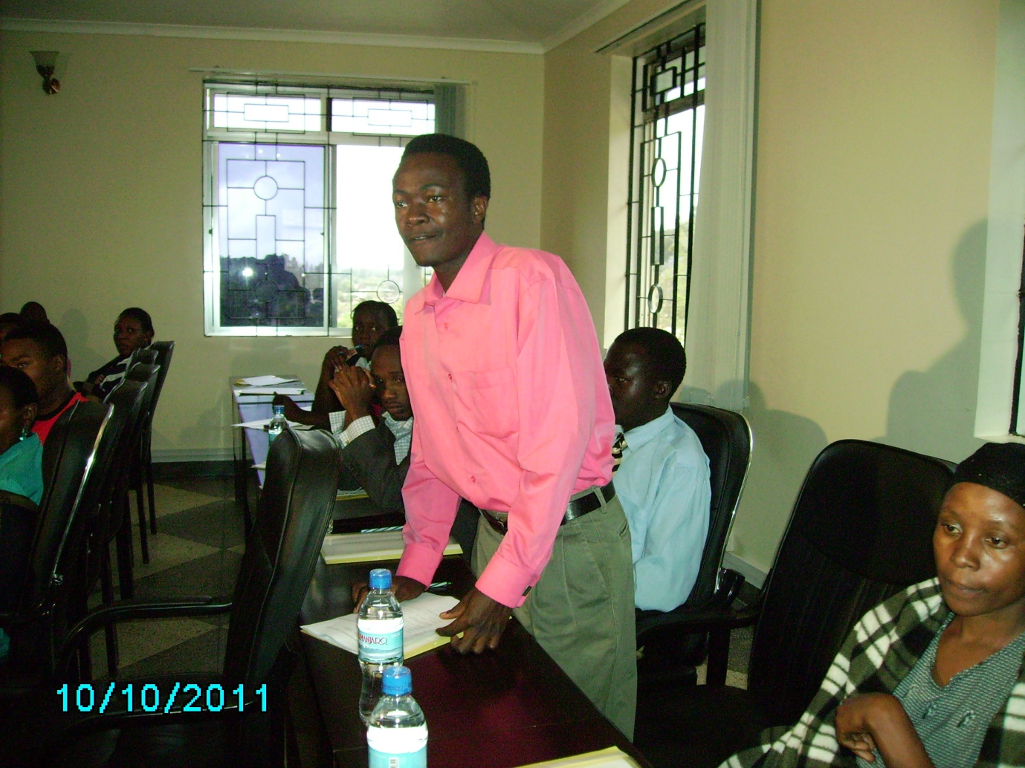
Member of youth parliament of Milingano ward, contributing his view during Lushoto election of parliament leaders

