Below: The pictures of the Water Development Committee reached through water resources management in Magoroto ward of Muheza District
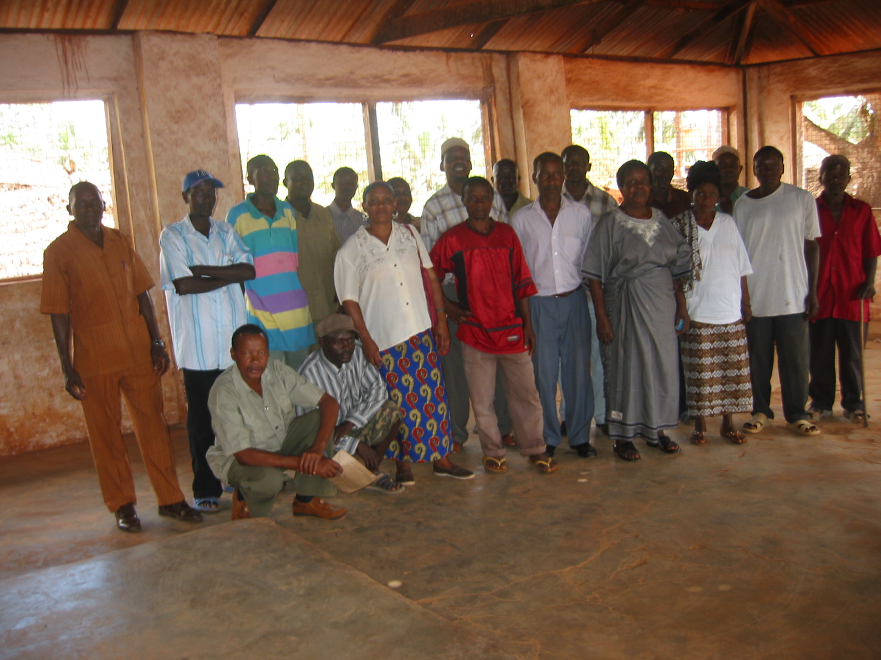
Below: Some Few members of the Lusanga water Development Committees who had earlier been empowered on water supply Resources management and Financial Book Keeping
