PROCEDINGS OF THIRD COMMUNITY AWARENESS RAISING METINIG ON ENVIROMEMTAL MANAGEMENT IN WEST DISTRICT THAT WAS HELD ON 25/06/2011 AT THE ALTERNATIVE EDUCATION CENTRE,
(RAHALEO ZANZIBAR).

- OPENING OF THE MEETING

The meeting started at 9:25a.m

Mr Hamza M.Omar, the CODECOZ Secretary gave brief remarks on CODECOZ in general and on the project that is on funded by the Foundation for Civil Society. He explained that this meeting is a continuation of activities that started earlier under the project. In this meeting 9 Shehias are covered, targeting Shehas their assistants and counsellors that deal with relevant wards covering the Shehias. The Shehias covered to day are:- Kibweni, Mwanyanya, Sharifumsa, Kihinani, Mbuzini, Chuini, Mfenesini, Kama and Mwakaje. The wards are Bubu, Mwanyanya, Mbuzini, Mfenesini and Kiembesamaki.
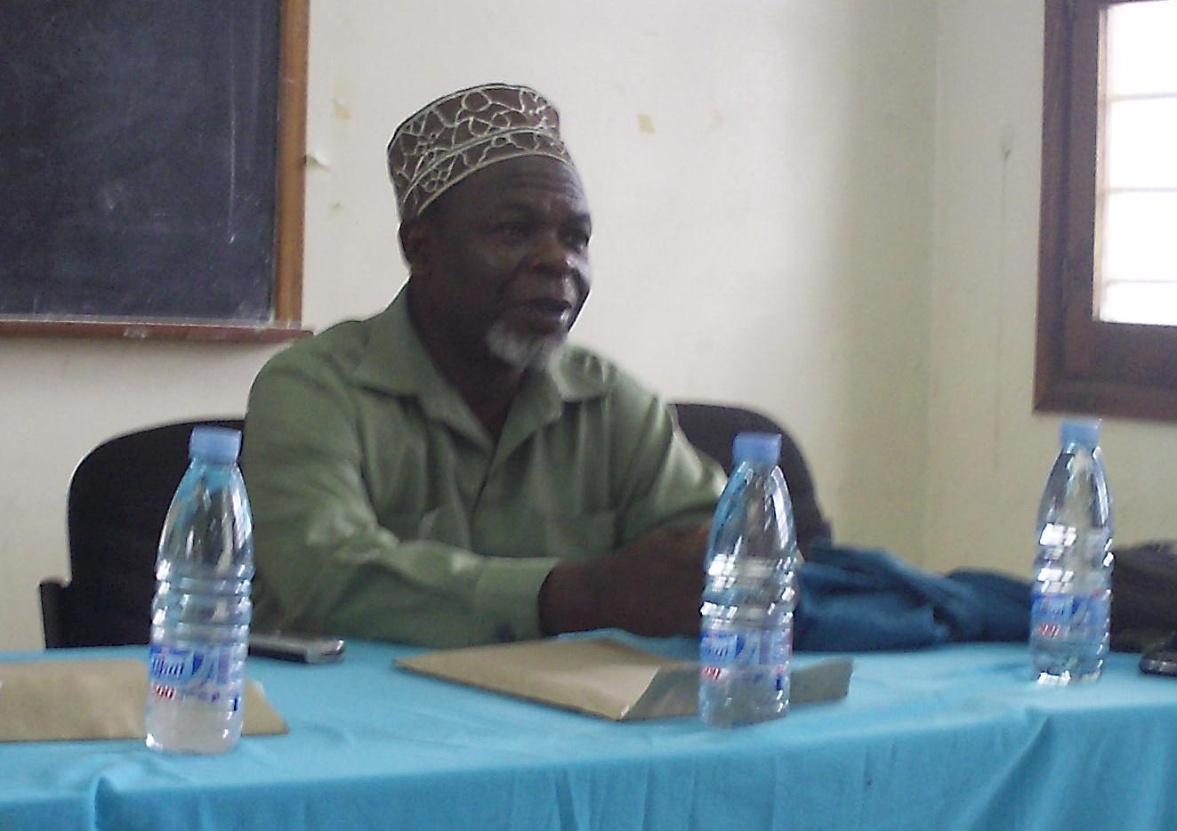
CODECOZ Executive Secretary briefing the participants on the activity

Invited Shehas are from Kiembe Samaki and Chukwani. He then invited the officer responsible for coordination of Government Issue in the West District, Mr Is-hak Kundi Ngwali to deliver few remarks and officially open the meeting. Mr Is-hak said that every one is responsible in their Shehias and wards. As leaders so they should impart the knowledge gained who then declared the meeting open.

1st Presentation: Role of Community in Environmental Protection Delivered by Ms Dhulfat Habib Ali and Mr Salim Kh. Said.

Ms Dhulfat H Ali stared by introducing the concept of Community and then explained the objectives of CODECOZ touching on vision and mission of the organisation. She highlighted on CODECOZ activities giving example Environmental Education. Like this community awareness meeting. She then dwelt on Environment and human being explaining the relationship between human being and his Environment. She mentioned how the human being utilises various resources that are available she also explained on the importance on mangrove forests and the Ecosystems. She then discussed on the effects of mangrove destruction to the Environment giving several examples.

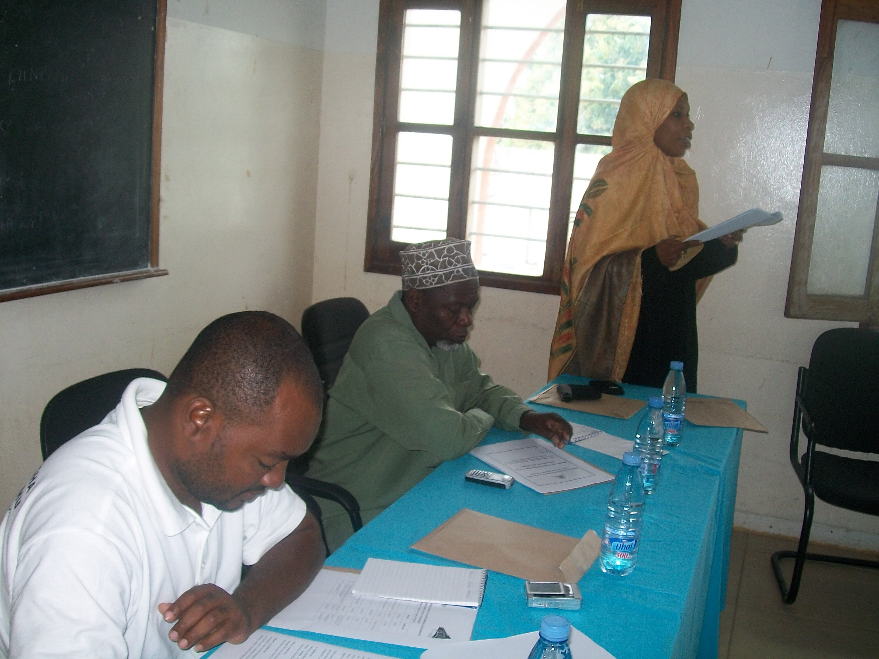
Ms. Dhulfat presenting a paper on the role of community leaders on conserving environment

She posed a question on why we should protect our Environment. She emphasised on the fact that if we do not protect our Environment it will be a threat to our lives and to the lives of the next generation and to our development at large. Legally we should protect the Environment as it an offence to destroy it. Religions we need to protect the Environment we live in as God has created the Environment first and then human being. So we need to utilize the resources sustain ably so that we don’t destroy the Environment in general.

Mr Salim started has part of presentation by explaining the importance of trees and protection of water resources cutting down trees is abundant in our areas. This contributes to desertification and water scarcity in affected parts of the Country. Encroachment near water sources is another Environmental hazard which contributes to epidemics like cholera. It is important to protect water sources so as to control water quality from those sources.

Mr Salim posed a question on who is responsible for protection of our Environment. Participants discussed on the issue and they everyone living in the West District is responsible in protecting the Environment the community, leaders groups NGO, CBOs and faith based organisation individually and jointly.

He then explained on how community leaders can participate in Environmental protection. He mentioned possible interventions that can be done by the community and their leaders. These include formulation of Environmental protection plan in the areas.

- Their involvement in policy formulation process
- Enactment of by laws to control Environmental distraction in Shehias.
- Policy and advocacy activities.
- Rehabilitation of areas that are destroyed by activities such as storescavation sand mining and tree cutting.

In conclusion, Mr Salim insisted that all of us who reside the West District. We can start with Environmental Education but later culputs should be dealt with according and legal measures must be taken against then.

The Secretary summarised the presentation done and then spoke on the Environment policy. He said that the policy exists since 1992 but it is not implement able as there are no legislation to support its implementation. The policy up to date is not yet reviewed to enable it cater for the current situation in the Country. He urged participants to advocate for Environmental policy so that it can be implementing able.

Participants contribution on Environnemental policy. Ms Msim, counselor for Mfenesini urged government to hasten the process of reviewing of policy and relevant legislation according to the current situation in our Country. A resolution was declared by participants that policy should be reviewed, and amended accordingly.

2nd Presentation: The Environmental Situation and the Existing Challenges Delivered by Mr. Hamza Zubeir Rijaal.

It started on 11:05 am.

He started his presentation by explaining the concept of Environment. He emphasized on life as a core of Environment and explained on the relationship between living things and non living things or generally land we can say Environment is with all that surrounds it; he also explained the relationship between Environment and human development.

He posed a question on what is the importance of Environment. He discussed on natural resources. He explained that natural resource is any thing that we use for our benefit, saying that natural resources are divided into two main parts. These are: -
- Zinazorejesheka e.g. humans, animals, trees.
- Zisizorejesheka e.g. sand, stones, gravel, petroleum etc.

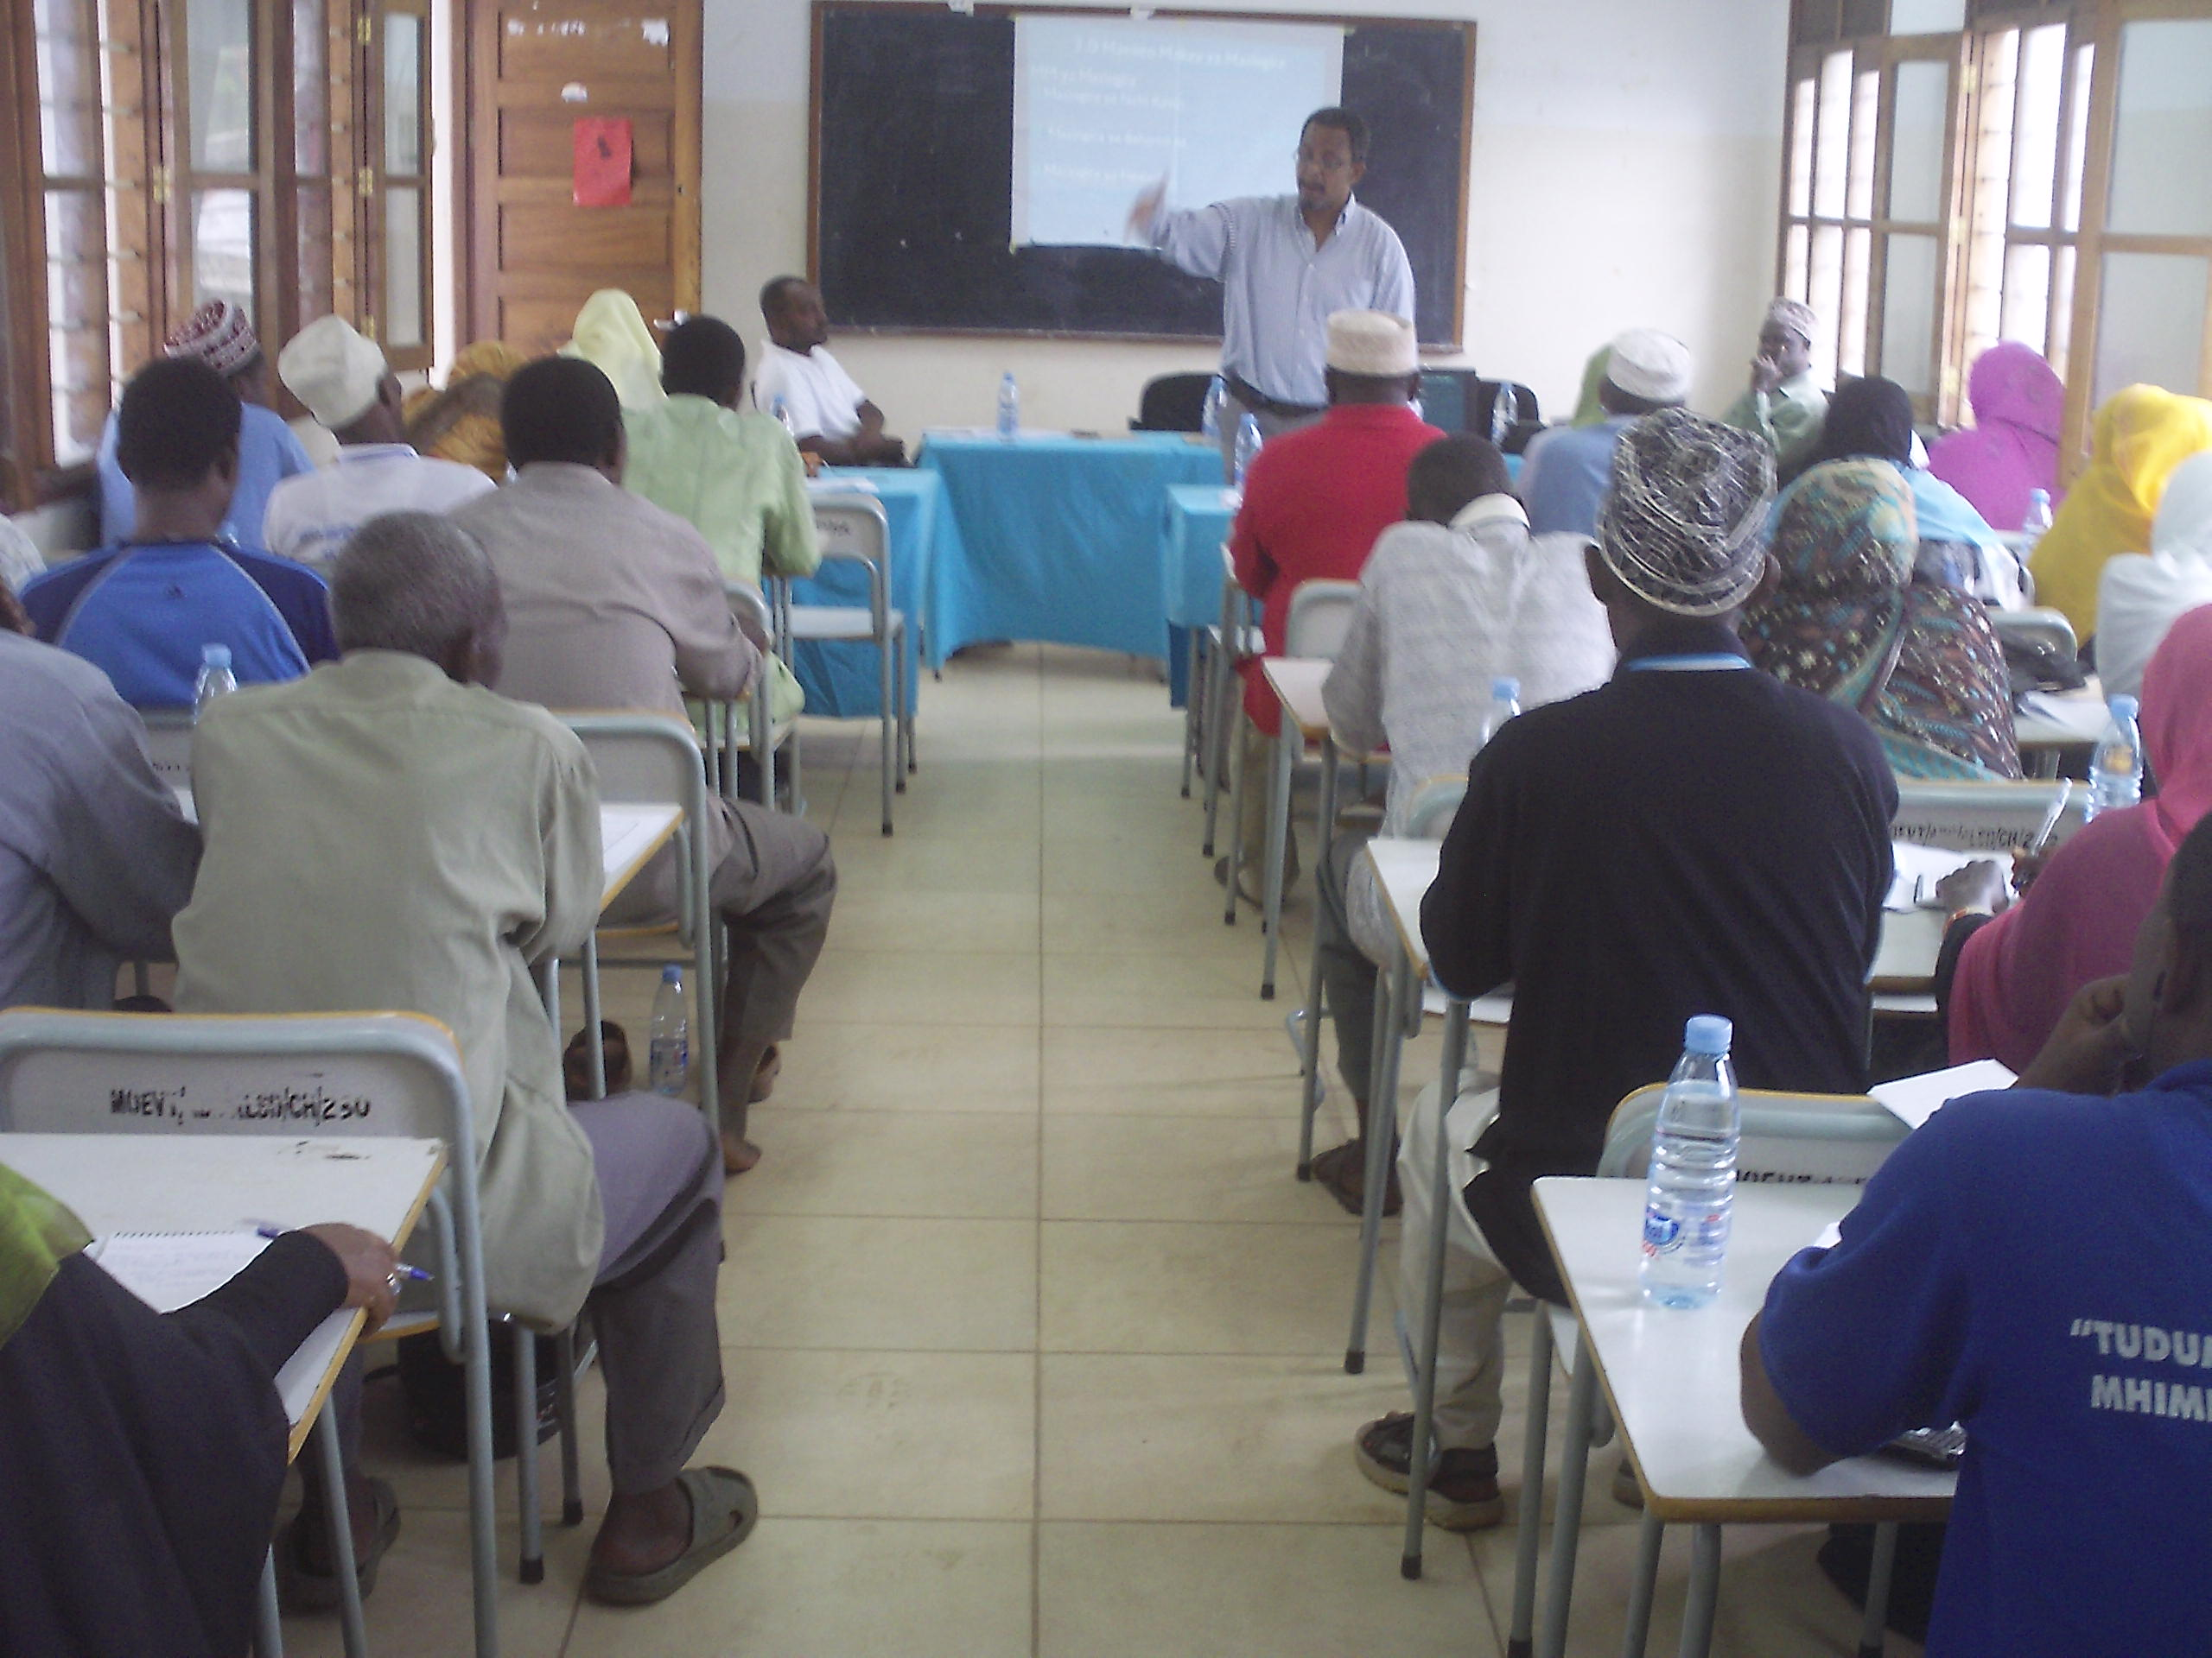
Mr Hamza Rijal presenting the paper on state of environment and challenges in West District
He then gave a detailed explanation on the relationship between human being and environment. He reminded participants on Zanzibar policy that was formulated in 1992. He explained that according to the Zanzibar Environmental policy there are 10 issues that should be considered when dealing with the Environment. These are: -

- Coral rang protection
- Coordination of water utilization and availability
- Drug control
- Coastal zone Management
- Coordination of natural resources
- Development protects should be coordinated
- Tourism activities should be Environmental friendly
- Mangrove forest controlled
- Sensitize mass conservation
- Provide Environmental Education to the policy.

He then discussed on Environmental Challenges that prevail in the Country being:

- Coastal and Beach erosion.
- Soil erosion
- Desertification
- Mangrove forest destroyed
- Sand collection and stone excavation
- Coral reef destruction
- Domestic wastes both solid and liquid wastes
- Squatters
- Illegal fishing
- Pollution
- Climate change

He dwelt on climate change as it is a global environmental issue currently. He
Explained that this is a trend which occurs after 30 years or more. He said that in Zanzibar now we are experiencing the following trend:-
- Change of climate
- Salivation of well water
- Decrease of fish population

He explained the concept of gas emission from Industries and other sources that causes global warming, which in turn causes climate change in various areas of the world phenomena such as earthquakes and volcanoes are common now. He advised participants to plant as many trees as possible, saying that currently there is a project (HIMA) which encourages people to plant the trees and they will be paid accordingly for their contribution to decrease of global warming.

He then cited environmental problems in the West District and discussed them with participants, who agreed on the prevalence of these challenges in their areas. They are not different from the National Environmental problems.

Conclusions

On conducting his presentation he urged all participants to take active part in Environmental protection and conservation. We should join forces of Government institutions, non Governmental Organisation, Community group and Community leaders to combat Environmental destruction in our areas for the benefit of present and nature generations.

GROUP WORK
Participants wee divided into four (4) groups and were assigned task to discuss and agree on by laws to be enacted so as to curb environmental destruction in Shehias especially regarding sand mining, domestic wastes disposal and tree cutting.

After group work, group secretaries presented their recommendations regarding the by laws formulation. The recommendations are as follows:-

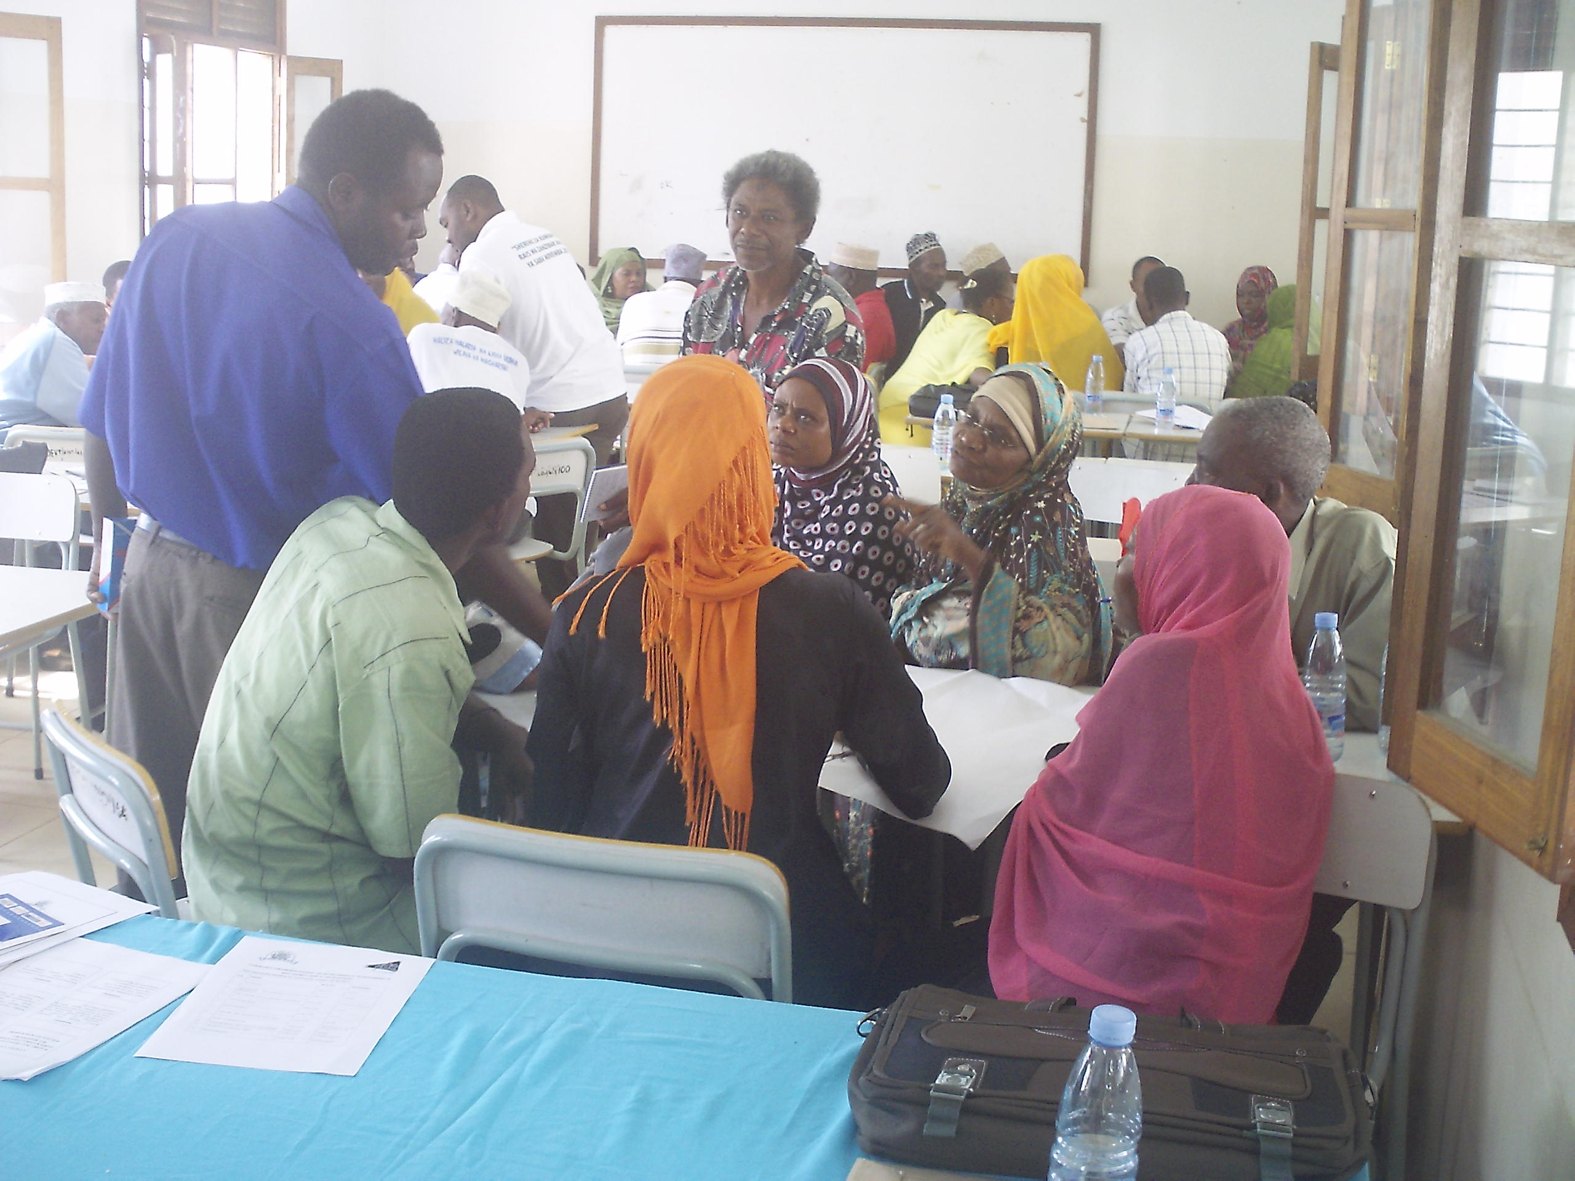
Community leaders during the group works

Michango ya Washiriki wa Semina Kuhusu Sheria Ndogo Ndogo (Bylaws) Tarehe 25/06/2011 Elimu Mbadala (Rahaleo) Zanzibar

- KUHUSU: UCHIMBAJI WA MAWE, UDONGO, MCHANGA
Yeyote atakaekamatwa na moja kati hayo au yote
- Kizuiwe chombo chake kwa manufaa ya au maendeleo ya Shehia
- Mchang au mawe au udongo utumiwe kwa maendeleo ya ujenzi wa Shehia.
- Atozwe faini kulingana na ukubwa wa tukio, ikiwa gari ndogo atyozwe 50,000/= na ikiwa gari kubwa atozwe 100,000/=.

- KUHUSU: MATUMBAWE, MIKOKO, AU MIKANDAA.
- Kwa kosa hili mhusika atozwe faini ya Tsh 50,000/= au Awekwe ulinzi kwa muda mpaka amkamate mwenziwe ili apewe yeye adhabu hiyo.
- Atangaziwe katika Shehia kwa adhabu hiyo ili iwe funzo kwa wote.

- UTAKAJI WA MISITU (HUSUSANI KWA KUTUMIA MSUMENO WA MOTO).

- Vifaa vyake anavyotumia vitaifishwe.
- Apate adhabu ya kupanda miti na kuishughulukia mpaka iwe.
- Atoe faini yenye kulingana na thamani ya miti.
- Adhabu zote kwa wakati mmoja

- UTUPAJI WA TAKA TAKA.
Kabla ya kutoa adhabu kwanza kuwe na utaratibu wa usafishaji mazingira na kwa asiye shiriki alipe faini ya Tsh 1,000/=. Na kwa atakae tupa taka kwa makusudi azowe taka zote na asafishe kwa mud a usiopungua wiki
- Atoe faini ya Tsh 2,000/=
- Asafishe eneo husika
- Apewe adhabu zote mbili

NOTE: Kwa makosa yote hayo mhusika alipe 300,000/= iwe ni funzo kwa wenginie.

CLOSING OF THE MEETING

The Chairperson, Mr. Hamza Zubeir Rijaal thanked all participants for their faithful discussions and promised to work closely with officers of the west district as well as community leaders in CODECOZ future under takings.
He then declared the meeting closed at 12: 55 noon

Prepared by

  - Mwanakhamis Kh Soud

  - Capt: Hamza M. Omar

