COMMUNITY AWARENESS RAISING ON ENVIRONMENTAL MANAGEMENT AND STRATEGIC PLAN DEVELOPMENT PROCEDINGS OF EVALUATION MEETING THAT TOOK PLACE ON 15th JULY 2011 AT THE ALTERNATIVE EDUCATION CENTRE, RAHALEO ZANZIBAR.

THE MEETING STARTED AT 3:25.am

- The CODECOZ Executive Secretary briefed members/participants on the objective of the meeting and requested the Chairperson to officially open the meeting.
- The Chairperson invited participants and urged them make critical analysis of the reports and air their views freely for the improvement of CODECOZ performance in its future undertakings.
Presentations were delivered by Capt Hamza M Omar (Rtd). He explained that this document is divided into 2 parts quarter 1 and quarter 2.

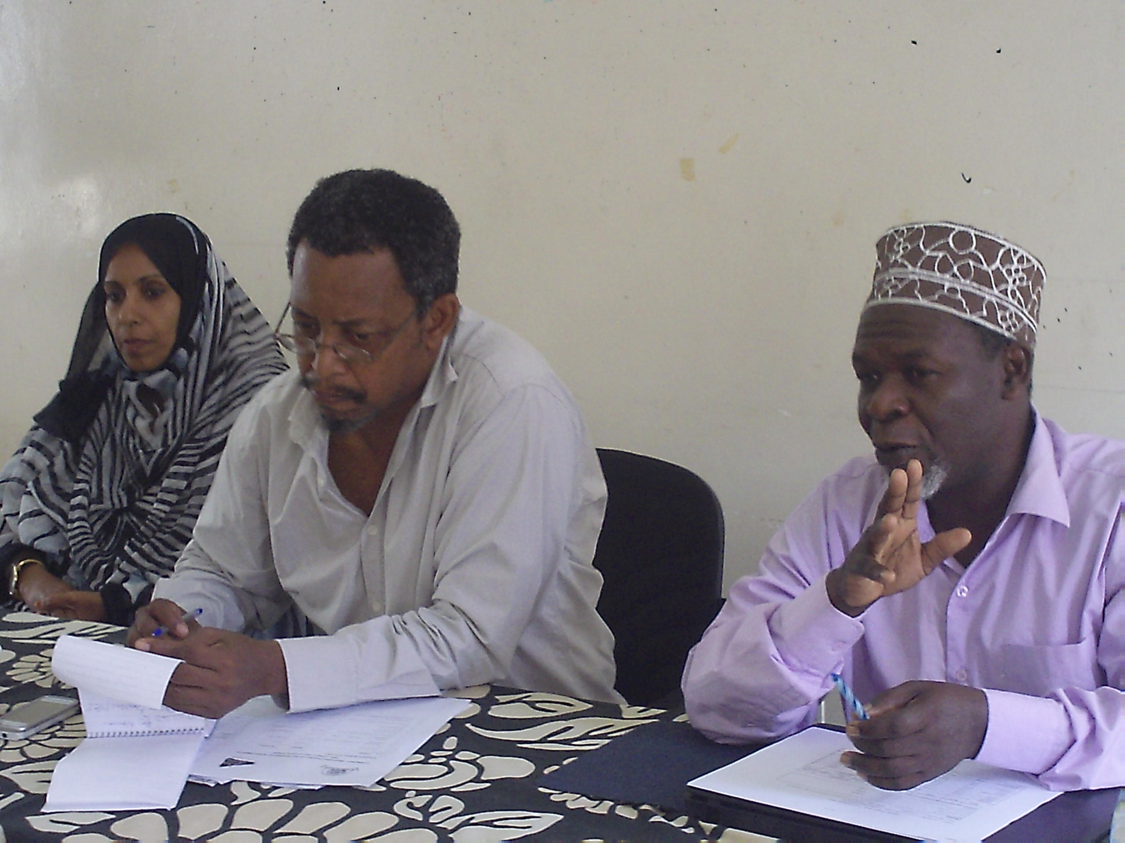
CODECOZ Executive Secretary briefing the participants on the activity

1st MORNITORING REPORT.

Capt Hamza M Omar reminded participants on the overall project objectives and highlighted quarter 1 objective mentioning methodology used and activities set to be implemented. He then explained on the status of implementation of all activities.
The activities include hiring of staff and purchase of office equipment; on day meeting to present findings / report by the consultant.
He highlighted achievements of the activities. He also talked on workshop to develop five (5) years strategic plan; saying that this intervention was successfully conducted and reached desired objectives. Major achievements of this activity include draft document of CODECOZ strategic plan developed, one year operational plan developed and knowledge / skills on facilitating.
Strategic planning was acquired

However there are challenges and constraints being little knowledge of most members on OCA some members know little on Organisations activities overlooking/under budgeting of some items like transport for members of Board of Trustees, supporting staff and fuel.

COMMENTS / RECOMMENDATIONS

- Topographical error to be corrected
- Style of writing should be systematic bullets or numbers
- The CODECOZ logo is purely marine. It lacks terrestrial issues. It can be discussed later if there is a need to improve or change it.

Pg 4 – under objectives of workshop No 1 and 2 have been merged to read as follows:-
“Gained knowledge and experience in formulating and facilitating strategic planning”

2nd QUARTER MONITORING REPORT.

It was presented by Capt. Hamza. He highlighted activities done being dialogue meeting with West District leaders and three (3) awareness meetings for community leaders of 29 Shehias and 15 wards of the West district. He mentioned the achievements and challenges

COMMENTS / RECOMMENDATIONS

- Numbering of items is important
- Topographical errors to be corrected
- There is no Mombasa ward but there is Tomondo ward.

Ms Salma Abdullah Presented Quarterly Report on Finances for the Period of 02 February to 01 May 2011.

Funds received TZS 19,745,500/=
Expended TZS 19,685,300/=
Balance at the and of period TZS 60,200/=

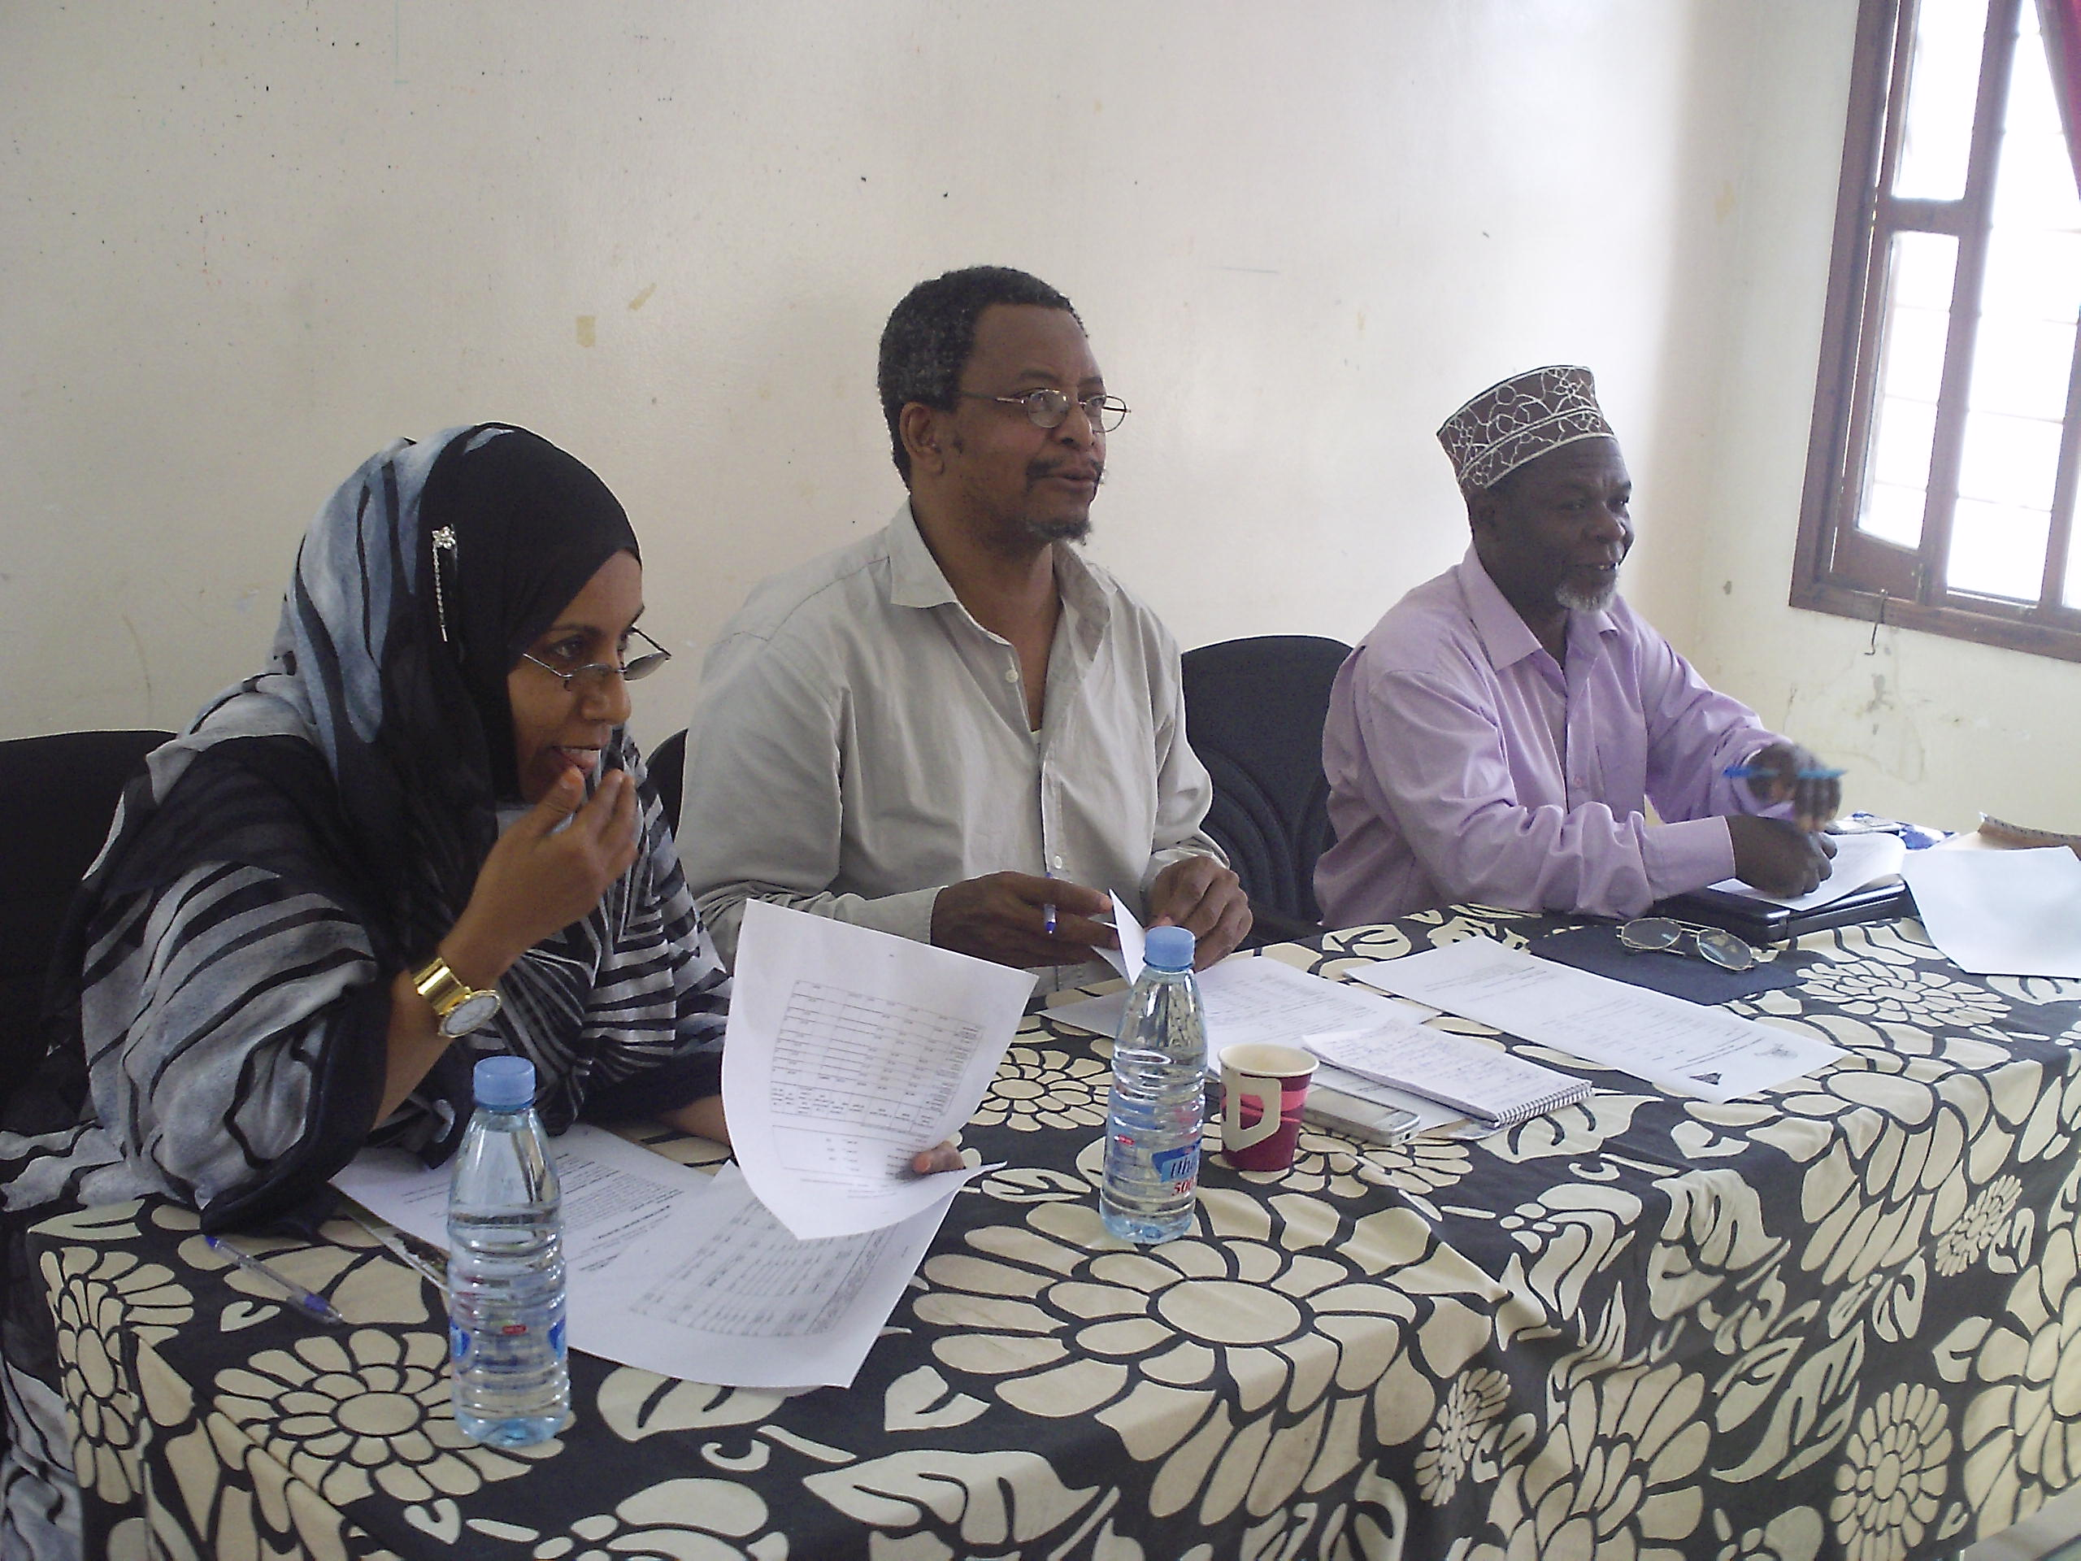
Ms. Salma presenting the financial report during evaluation meeting

She went and explaining on how funds were expended in major activities i.e.

- 3 day Organisation Self assessment
- One day meeting to present report findings by consultant.
- Conduct 5 days workshop to develop 5 years
- Strategic plan
- Administration costs

COMMENTS

- Capt Hamza provided more elaboration on monitoring and evaluation reports. It was generally noted that the format brought to the meeting is too technical. So in next presentations simple excel version should be used to make it more understood by participants.
- CODECOZ should strive to improve performance
- CODECOZ was congratulated for its efforts but was advised that issues agreed upon should be disseminated to all parties.
- Mr Hamza M Omar said that the report has already been submitted to FCS and 3rd instalment has been disbursed to CODECOZ account.

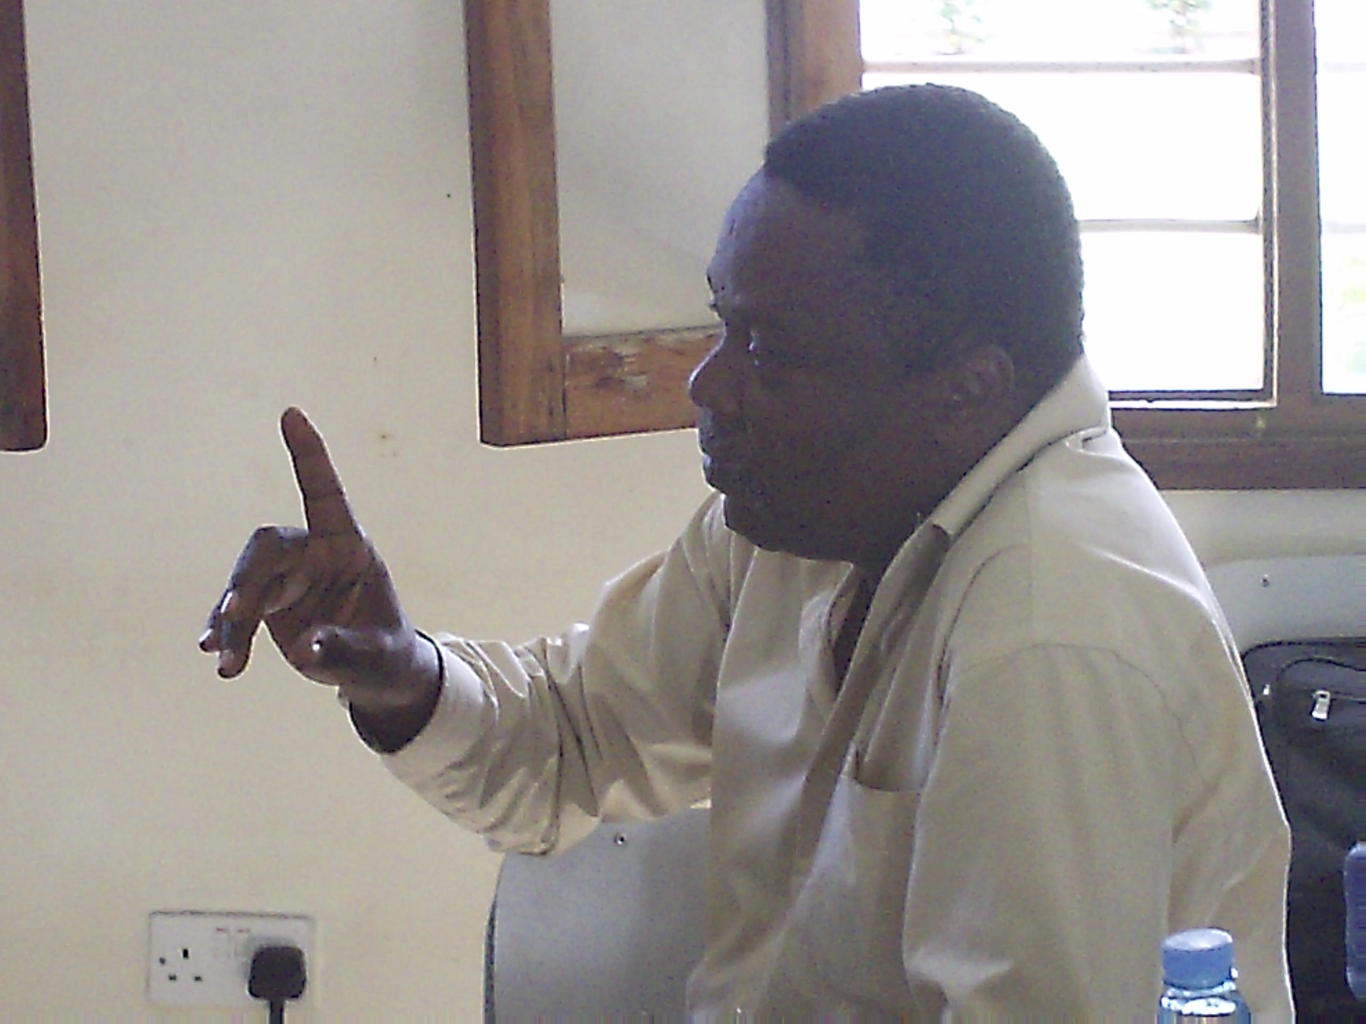
Dr. Salim M. Muhammed member of the board of trustee contributing at the meeting

Chairperson agreed on the comments and recommendations of participants and promised that CODECOZ shall work on the issues raised with the aim of improving CODECOZ performance in future CODECOZ should work as a team and avoid such circumstances better understanding.

Then the Chairperson closed the meeting at 11: 45am.

Prepared by
- Mwanakhamis Kh Soud.
- Capt. Hamza M. Omar

