PROCEDINGS OF A 5 DAYS WORKSHOP ON STRATEGIC PLANNING THAT TOOK PLACE FROM 22nd – 26th APRIL 2011 AT THE OFFICE OF CHIEF GOVERNENT STATISTICIA CONFERENCE HALL; MWANAKWEREKWE ZANZIBAR.

DAY ONE- 22/04/2011

The session started at 9:15 am.
OPENING OF THE WORKSHOP

CODECOZ Executive Secretary welcomed participants and gave a brief on the workshop objectives. He asked participants to introduce themselves, saying that in this workshop besides members, other stakeholders including representatives from Department of Environment, District Authorities’ (both Central and Local government) Community leaders (Shehas) of Chukwani and Kiembe Samaki and media personal have been invited to attend the workshop. He then gave the podium to CODECOZ’s Chairperson who officiated the opening the training.

In his short opening remarks the Chairperson urged participants to be attentive and active in the whole process as strategic planning is important for CODECOZ because we expect a document which shall guide us in our future undertakings. He then declared the workshop open.

PRESENTATION

The facilitator, Mr Rashid Said that in this process we need to relate the findings OSA. That was conducted earlier. He highlighted the objectives of the workshop (outputs) as follows:-

- Gain knowledge and experience in formulating Strategic Plan.

- Acquire skills on facilitating Strategic Planning.

- Sensitized on how to think strategically.

- Produce draft document of CODECOZ Strategic Plan.

He said that the process of strategic planning is highly participatory, so he expects participants to contribute a lot.

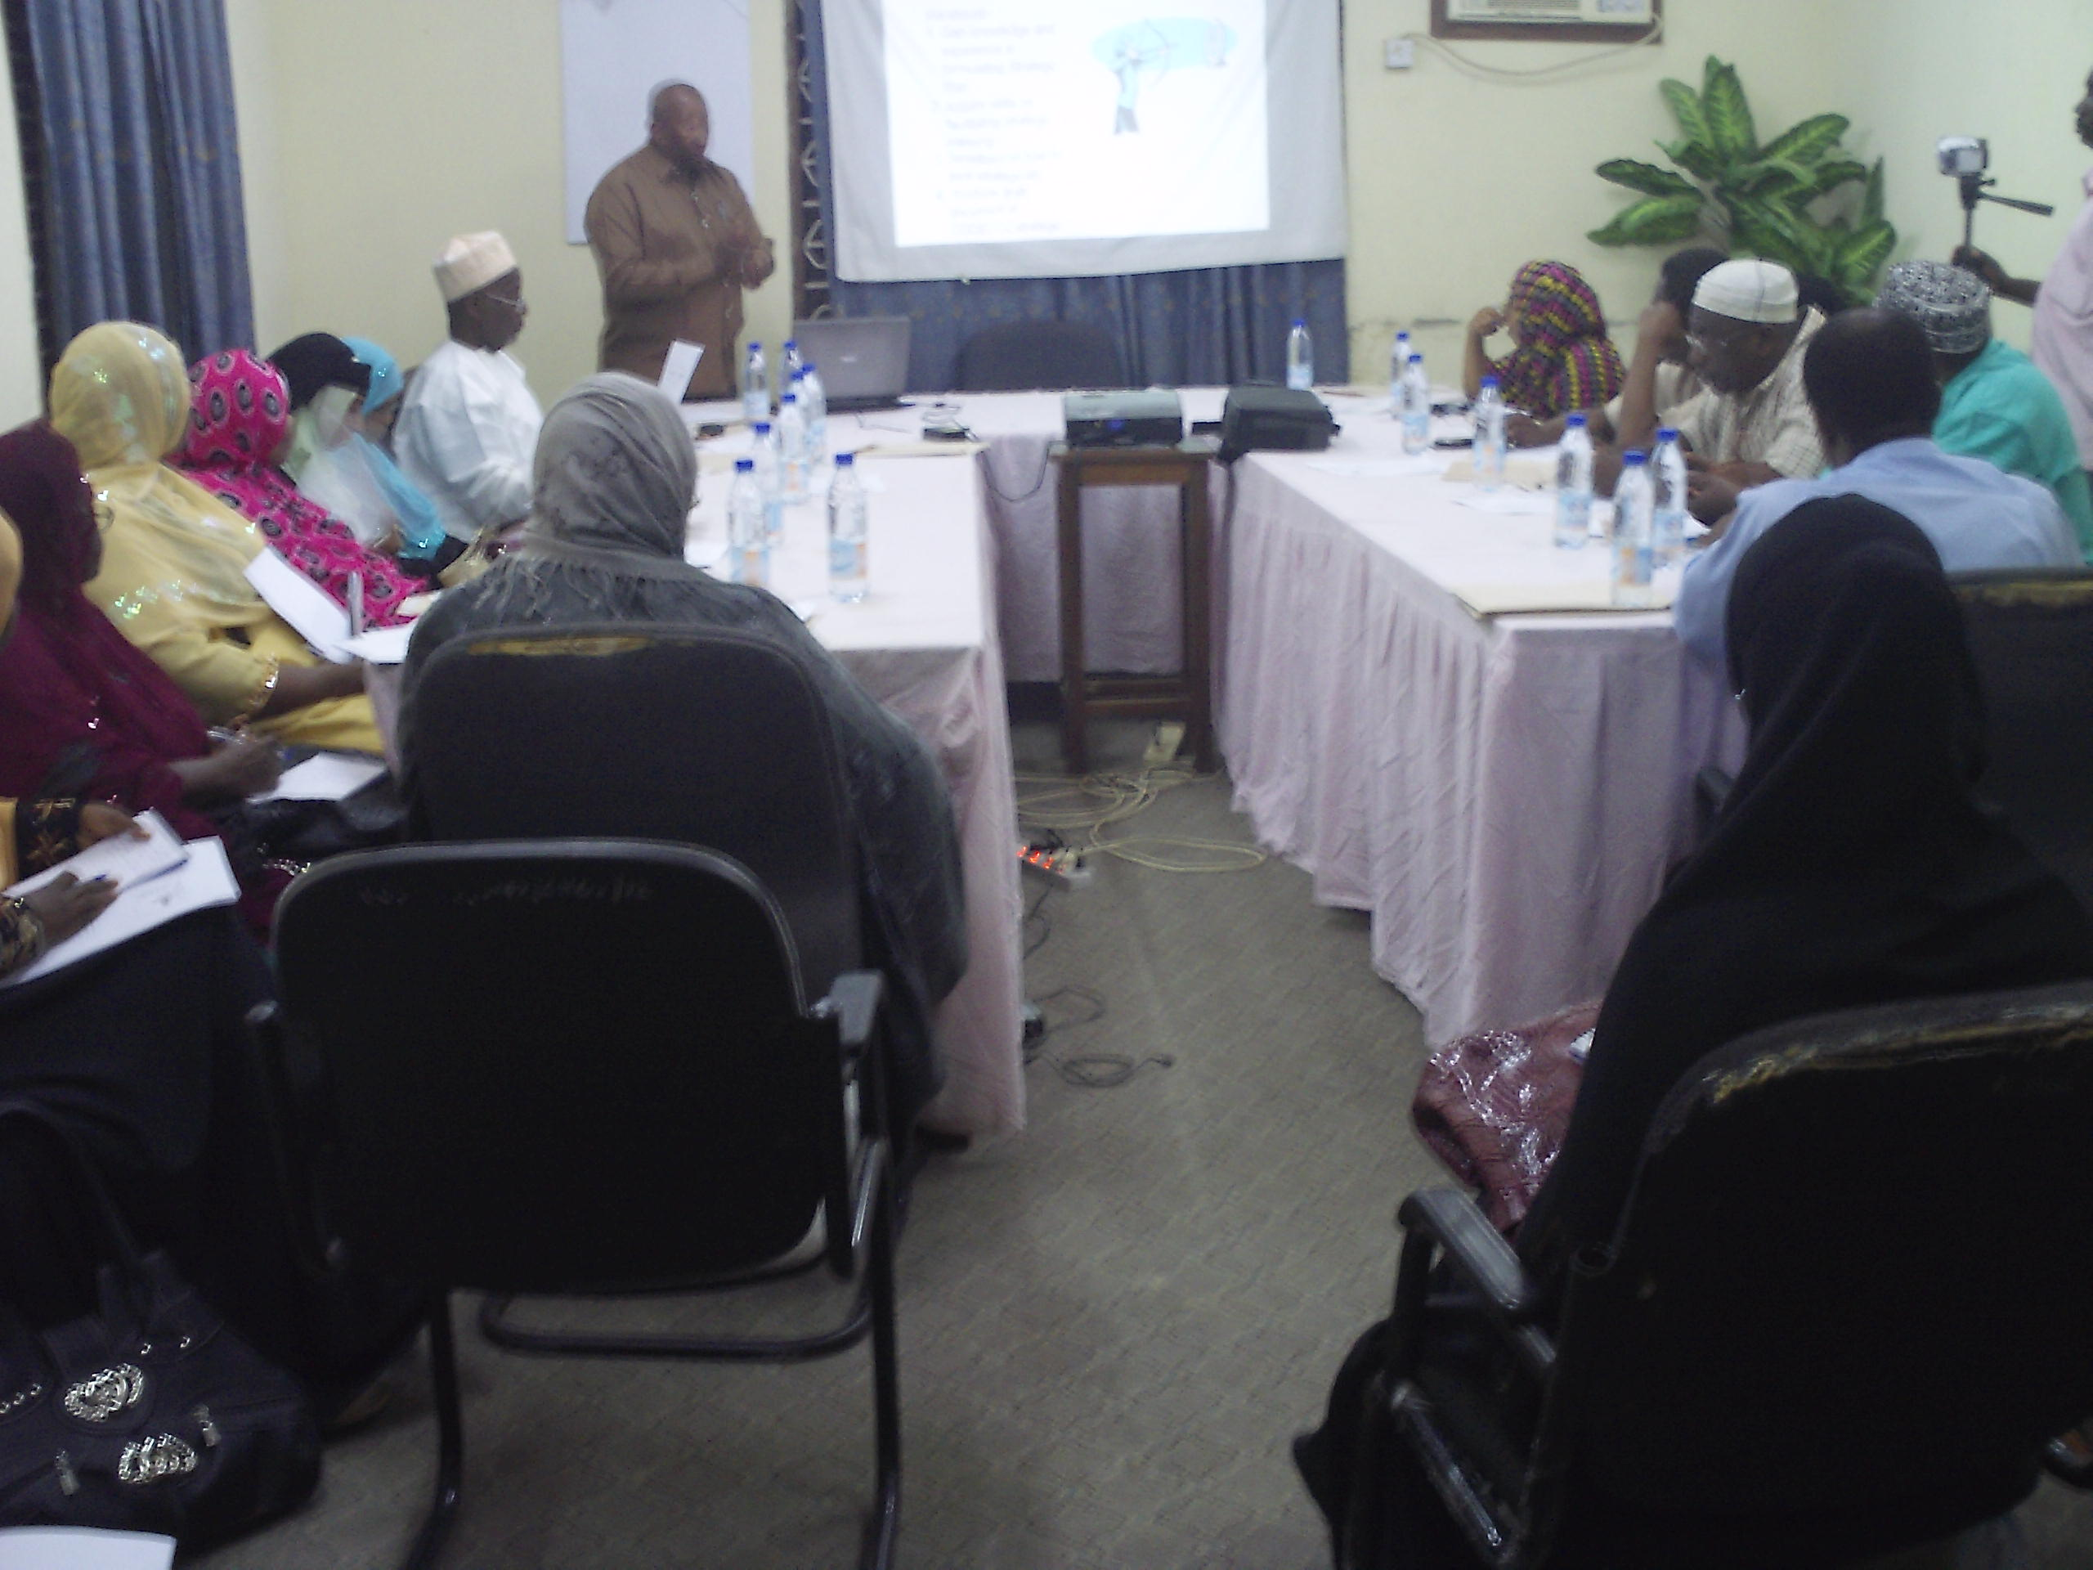
The picture shows Mr. Rashid presenting the paper on steps of developing S.P

INTRODUCTION

He started by introducing the concept of Strategic Planning and then explained on the important steps of the process. The 6 steps are as follows:-

- Getting Organised

- Conducting situation analysis

- Focusing

- Budgeting

- Implementation

- Monitoring and Evaluation

He went on explaining the concepts of starting with the 1st step and covering up to 2nd step in day one.

Regarding situational analysis he said that we need to answer 6 questions (5w + 1H) i.e. Who, What, When, Where, why, and How.

Participants were divided into 4 groups and were asked based on TOSA findings to do the environmental scan (SWOT) of the organisation so as to identify its Strengths, weaknesses, opportunities and challenges. Group presentations were done, followed by plenary discussion. Then the facilitator explained another methodology that is used to analyse the organisational situation ie PEST. (Political, Economical, Socio cultural and Technological aspects). Group work was also done on PEST.

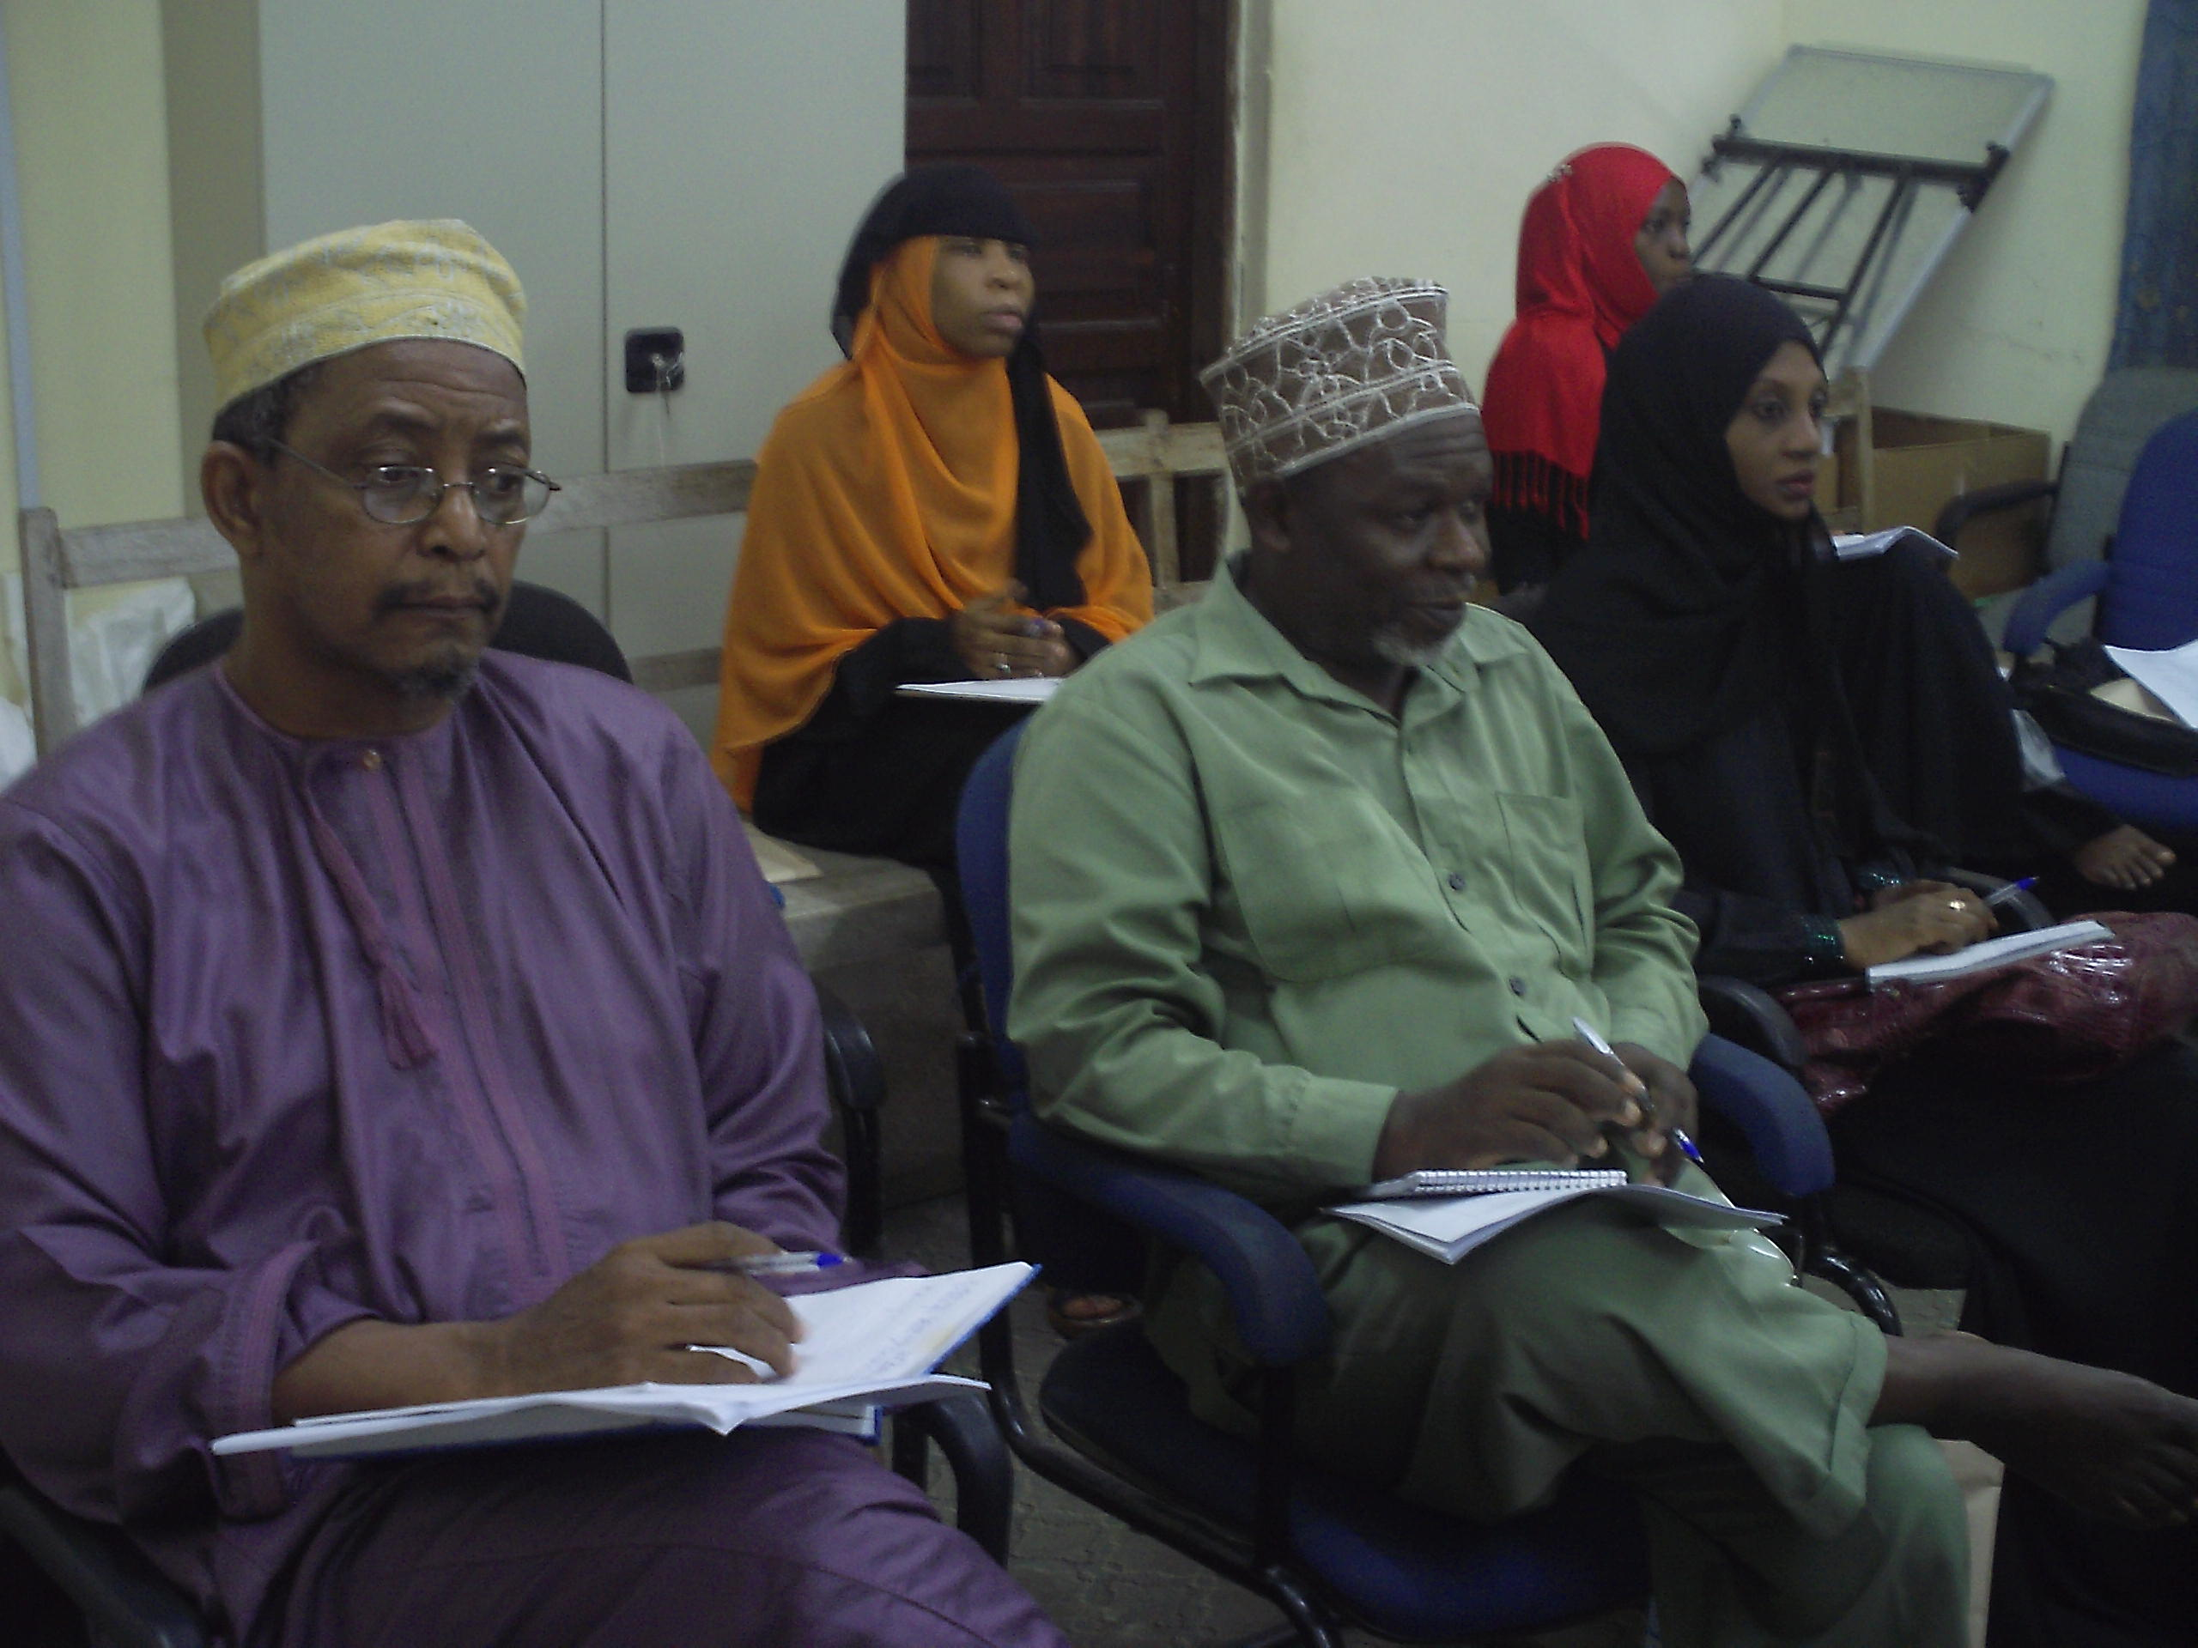
A cross section of CODECOZ members attentively listening to the presentation of the facilitator at workshop

Presentations and discussions were made and then the facilitator explained on stakeholder analysis. He guided participants in doing an exercise through group work, whereby they were to identify stakeholders of different categories being:-
- Low Important, Low influence
- High Important, Low influence
- Low influence , High influence
- High Important , High influence

After representations and discussion the sessions was adjourned till next day.

DAY TWO – 23 /04/2011

The session started at 9: 05 am with a recap of day one which was delivered by one of the participants.

The Chairperson thanked all for coming in time and argued them to be attentive and active in day’s discussions.

The facilitator reminded participants on the process of strategic planning. He mentioned the 6 steps and highlighted the 2 steps covered in the previous day i.e. getting organised and conducting situational analysis within the organisation and outside the organisation meaning strengths weakness, opportunities and challenges (threats) and how the participants analysed these aspects in the previous sessions.

He started with the 3rd step – i.e. focusing saying that we need to develop on vision He elaborated on the concept in following aspects: -

Introduction
- Characteristics of good vision – simple, relevant and attainable.

He urged participants look deeply into CODECOZ vision and if necessary try to improve it.
There were hot discussions on better versions of the vision. Ultimately we agreed upon the new version as “Healthy and Sustainable Environment for Better Life of Zanzibar Community”

He then talked on Bridge Model, The idea of vision as a target across the river and we want to cross the river using a bridge. He urged participants to ask the following questions.

- Where are we now? This is the situation analyse
- Where we want to be? This is the vision
- How are we going to get there? This is the strategy
- What skills do we have? What resources do we have
- What do communities need? Target

Issues of planning, finance Community mobilisation are important in facilitating the attainment of our vision

. 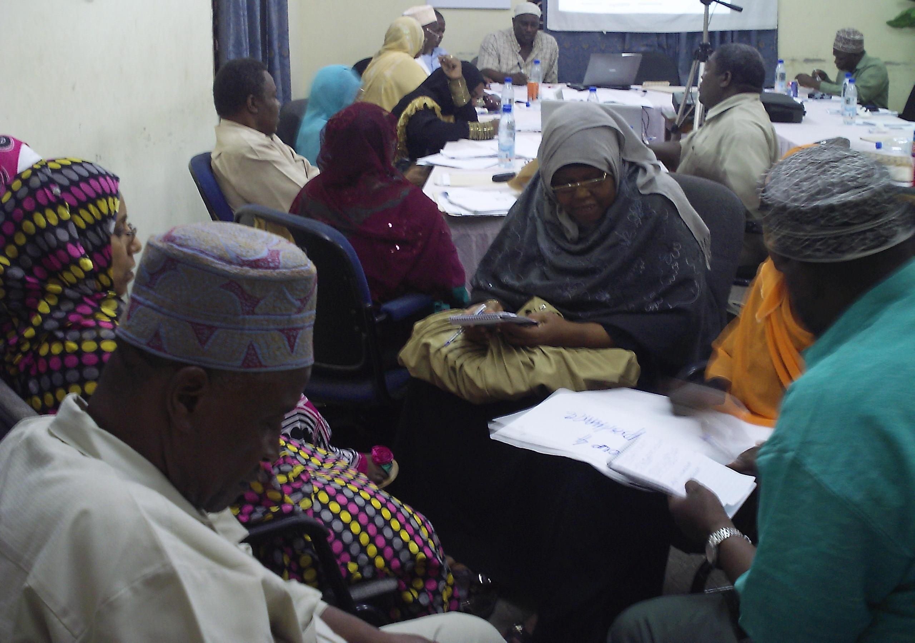
Groups discussion in progress during S.P development at the workshop

BUILDING OUR PILLARS

These are program components that will help us to achieve our vision.

He then highlighted on mission skiing the participants first on how they understand the concept. He then defined and explained on Mission and insisted that vision and Mission must be linked.

Mission should capture the following information

- Who you are?
- What kind of work you do
- Your key beneficiaries
- Your area of operation

Participants discussed on the new version of the mission and agreed upon the following: -

CODECOZ intends to promote active participation of the community in environmental management by raising their awareness through environmental education, lobbying and advocacy and assist communities in formulation and implementation of the community based environmental friendly/ sustainable development projects.

The facilitator highlighted on Program Development explaining the concepts citing existing program areas of CODECOZ.

Program areas mentioned are as follows:-

- Research Monitoring and Evaluation
- Education and Community outreach
- Administration and finance
- Project planning and Management
- Lobbying and Advocacy
- Consultancy services on environmental issues / projects

He then explained on the logic Model comprising of inputs, outputs outcomes and impact, (short term, long term, medium term) assumptions and external factors.

He then guided the participants in looking into how we can prioritize by referring to the situation we have.

We should work into the following aspects:-

Problem or issue that the program addresses
- Inputs
Outputs
- Outcomes - results changes for individual’s groups and agencies communities’
systems short, medium and long term.
- Assumptions: These are beliefs of program, people, environment and the way we think the
Program will work.

External factors: This is the environment, in which the program exists,
Outputs and Objectives: These are formulated in past tense they are in desire results in future. Eg Increase number of trees planted. They may be qualitative as well quantitative.
Indicators: are things that point to successes and failures they measure performance

There are quantitative and qualitative indicators.

The facilitator wanted the participants to refer to MKUZA II and TOSA findings as well as situational analysis done previously, before developing the program. He also mentioned a review of the Environment policy.

He insisted that there must be a strategic link in all these aspects.

High guided participants to look into the 5 main program areas and see what changes we need to see in group work. Each group has to discuss one program area.

Groups

- Research and monitoring Evaluation
- Education and Community Out reach
- Project Planning and Management / Consultancy Services
- Lobbying and Advocacy
- Finance and Management.

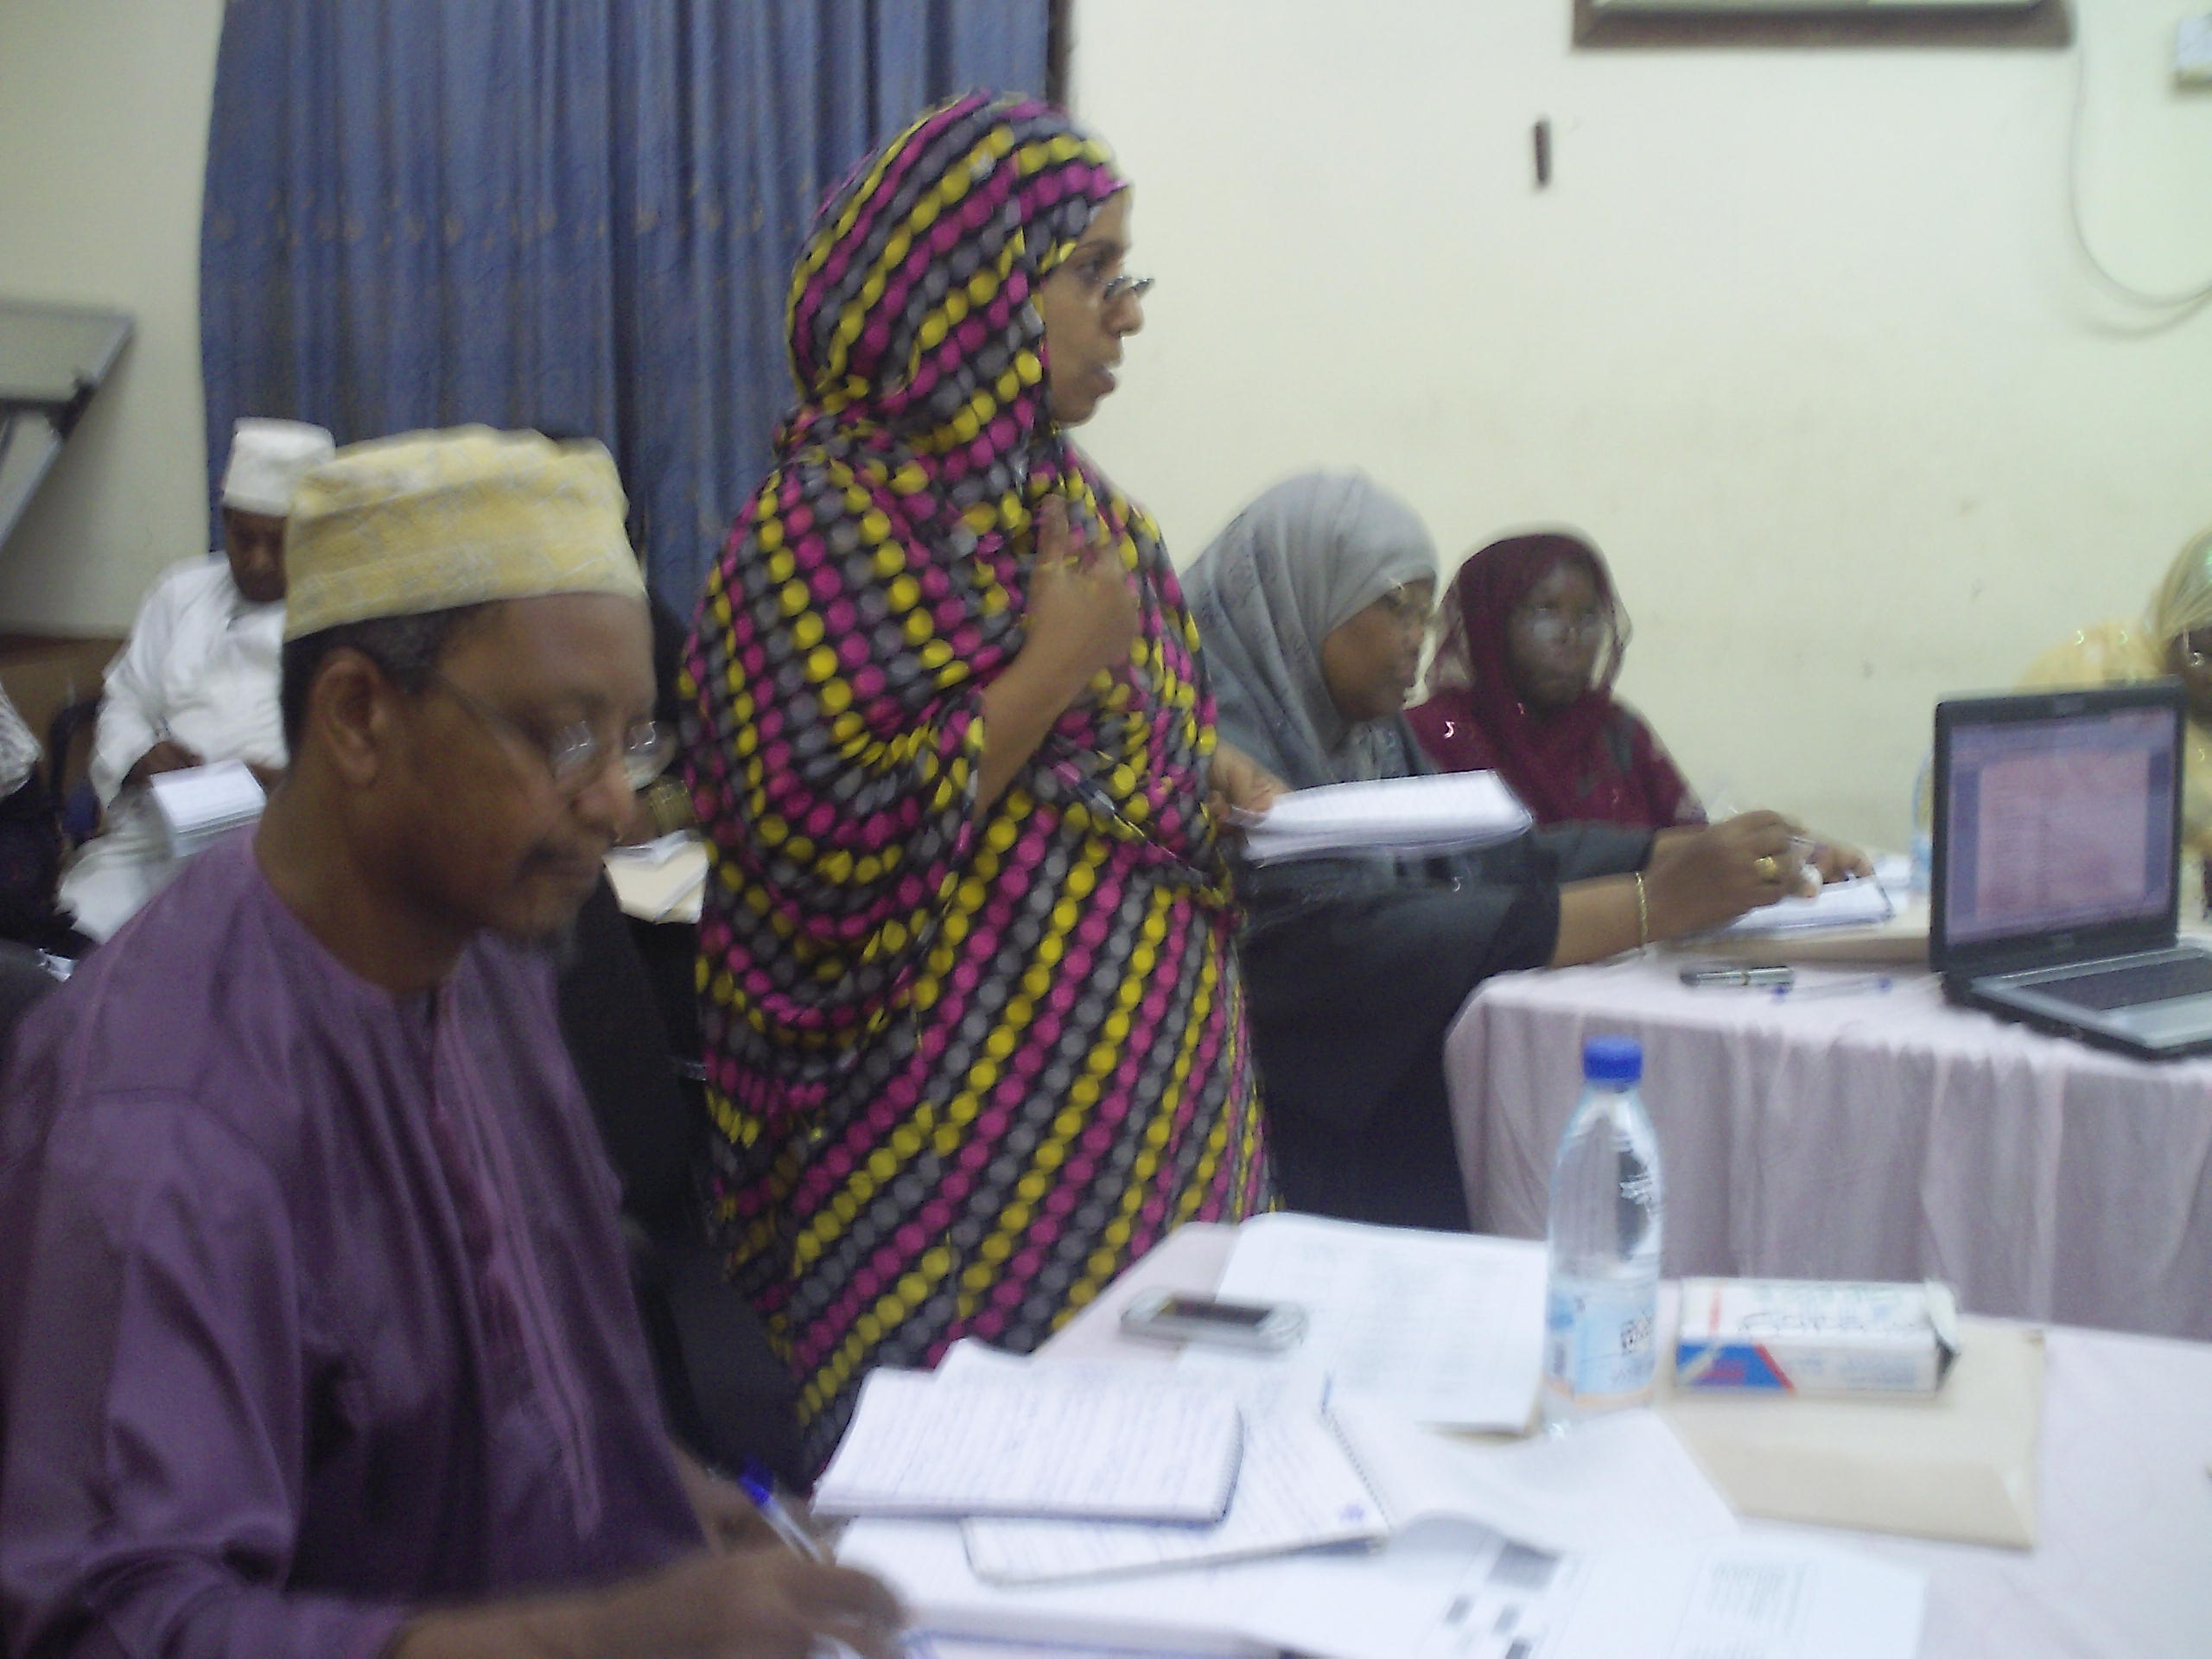
A participant presenting the work of her group

Then group secretaries presented their work whereby they were asked to come up with outputs and objectives of specific programme area. The participants discussed and improved the finding from different groups.

The facilitator then guided participants on determining activities for the set objectives.

He also remained the participants on selling indicators for the activities Group work for determining activities followed after which the day’s session was adjourned around 4:00 pm till the following day.

DAY THREE – 24/04/2011

The chair person welcomed participants at 9:05 am; this was followed by the recaps of previous session which was presented by one of the participants.

There after group secretaries presented their work.

- The group which was assigned Education and Community Outreach programme area presented the activities which group has come with. Then discussion on the presentation was done consensus reached on actives to be dealt with by the organisation.
- The group on Project planning and Management Consultancy services presented its activities and were agreed upon after Long discussion and small changes.
- The group on Lobbying and Advocacy also presented its work it was discussed and agreed upon with minor modifications.
- The group on Research, Monitoring and Evaluation presented its work to the plenary and the activities were agreed upon with minor changes. One participant volunteered to work on finance and Management and he presented his suggestions which were discussed and basically agreed upon.

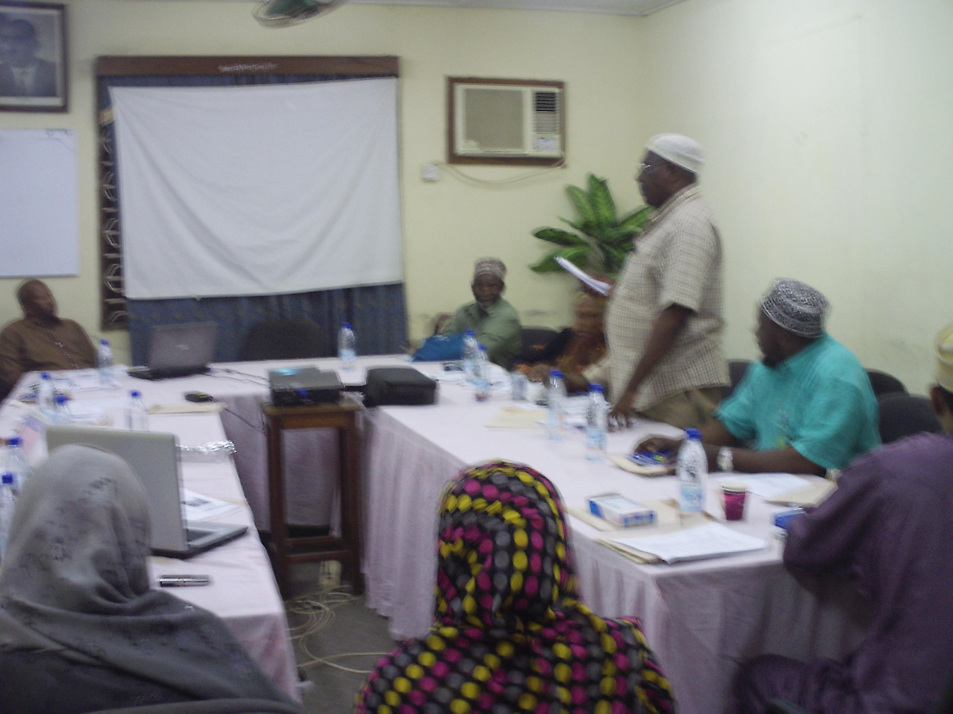
A participant presenting the work of his group

DAY FOUR - 25/04/2011

The session started at 9: 10 am with recap of day three (3)

Resource identification

The facilitator highlighted on budgeting of planned activities. He said that budgeting means making a financial plan. Things to consider are activity, resource base and resource mapping.

A good way to do budgeting is to look at the items needed, quantity, cost per unit price and total costs.

Groups were assigned to do budgeting for their respective programme areas.
It was urged that consultancy changes should be not less than 250,000/= per day and venue 100,000/= day transport last 20,000/= per day.

The facilitator asked the participants to present their group work. All groups presented their budgets and were discussed and agreed upon.

The facilitator then explained on step 5 of strategic planning ie Implementation. There is a need now to set indicators for performance. He refers to the participants the handouts for guidance on the exercise.

Then he explained the concept of Monitoring and Evaluation which is the last process in strategic planning. Participants went into groups to set indicators and later presented their work in plenary and discussed the findings.

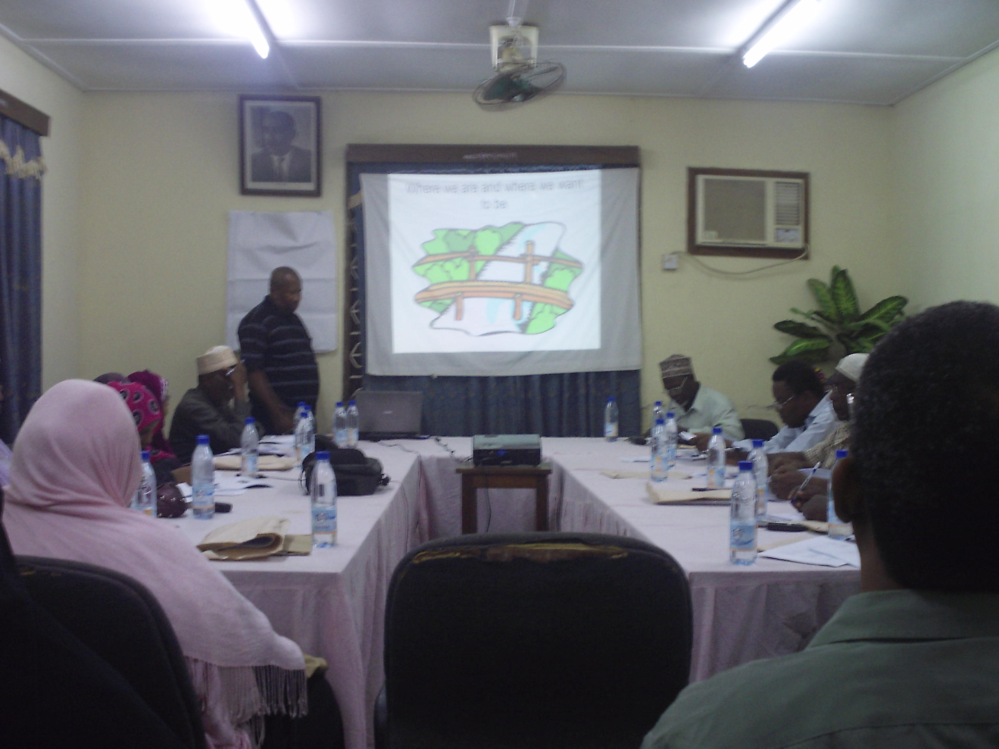
The picture shows Mr. Rashid presenting the paper on ResourceMobalization.

DAY FIVE- 26 /04/ 2011

The participants continued with the presentation of their group works which was followed by plenary discussion. The group were then asked to prepare work plan for the implementation of the strategic Plan

CLOSING SESSION

The Secretary asked the Chairperson to deliver his remarks to enable the facilitator to wind up the exercise of Strategic Planning. He thanked facilitator for guiding CODECOZ members to acquire at last the draft document of Strategic Plan for our organisation.

He thanked the Foundation for Civil Society for their support and also commended members for their active participation. He also expressed his thankfulness to our stakeholders who have been with us during these five days. He specifically thanked the Board members Dr. Narriman and Dr. Salim for being with us all along.

Mr.Rashid thanked CODECOZ for inviting him to conduct the workshop on Strategic Planning. He said that acquiring skills depends on individuals and therefore each has grasped the material according to his/her capacity.

The Chair person invited Mr.Sheha Mjaja, the director of Department of Environment to deliver a closing speech.

Mr.Sheha thanked all participants and organisers of this workshop. He specifically commended. The Foundation for Civil Society for the financial support. He also thanked Bord members who dedicated their time contributing to the Strategic Plan that was being formulated during the five days.

Mr. Sheha being the Director of Environment Department, urged members of CODECOZ and the public in general that they should act against environmental destruction practices in Zanzibar. He cited examples of brick making out of rocks in Pemba, gravel and sand mining which are on the increase.

He mentioned about Climate Change and its effect to the Coral Reef and the Creatures living in those environmental hazards. He called upon CODECOZ members to increase their efforts to words environmental education so as to curb the environmental hazards like E wastes - Computer dumping and other electronic wastes which are the major environmental challenges currently and pollute water that is used by people around those areas.

He thanked CODECOZ for being in the frontline in planning for 5 years to
Seriously address Environmental challenges in our country.

He called upon CODECOZ leaders to work closely with the Department of Environment and promised that the Department will assist CODECOZ in its undertakings as much as possible.

He asked reminded CODECOZ member to participate in the commemoration of WED this year after sasying that he declared he meeting closed.

LIST OF PARTICIPANTS
S/N | NAME | ORGANISATION
1 | Mwanamvua M. Hassan | CODECOZ
2 | Mwanakhamis K. Soud | CODECOZ
3 | Dr. Salim M. Mohammed | BOARD MEMBER
4 | Dr. Narriman S. Jiddwi | BOARD MEMBER
5 | Capt. Hamza M. Omar | CODECOZ
6 | Hamza Z. Rijaal | CODECOZ
7 | Judama S. Khamis | CODECOZ
8 | Fatma S. Khamis | CODECOZ
9 | Salim Kh. Said | CODECOZ
10 | Dhulfat H. Ali | CODECOZ
11 | Rashid O Hassan | TVZ
12 | Halima A. Omar | ZANZIBAR LEO
13 | Sheha M. Juma | CODECOZ
14 | Ramadhan A Bakari | TVZ
15 | Asha M. Juma | CODECOZ
16 | Fatma M. Abdallah | CODECOZ
17 | Mohammed A. Masoud | CODECOZ
18 | Fatma M .Moh’d | CODECOZ
19 | Mgeni Kh. Kombo | CODECOZ
20 | Semeni M. Khamis | CODECOZ
21 | Juma Kh . Faki | CODECOZ
22 | Amoun U. Mdowe | CODECOZ
23 | Juma B. Alawi | CODECOZ
24 | Othman B.Sheha | CODECOZ
25 | Abdi A. Seif | CODECOZ
26 | Mehra M. Hemed | CODECOZ
27 | Fatma O. Khamis | CODECOZ
28 | Maryam Th Ramadhan | WEST DISTRICT
29 | Suleiman M Mwinyi | SHEHA-CHUKWANI
30 | Mwinyi Kh Juma | SHEHA-K/SAMAKI
31 | Hassan H Hassan | DoE
32 | Iddi M Uledi | DISTRICT COUNCIL
33 | Hidaya Kh Ali | STZ

