PROCEDINGS OF PRESENTATION OF TOSA FINDINGS AND INTRODUCTION TO RESOURCE MOBILISATION THAT WAS CONDUCTED AT THE EACROTANAL ON 20TH MARCH 2011

OPENING
The meeting started at 9:25 am as per programme. The Secretary gave a brief explanation of the activity and then hand over the floor to the Chairperson who delivered the opening remarks. The Chairperson thanked the facilitator for timely submission of the report and urged participants to go through it and provide their inputs so as to improve the report.

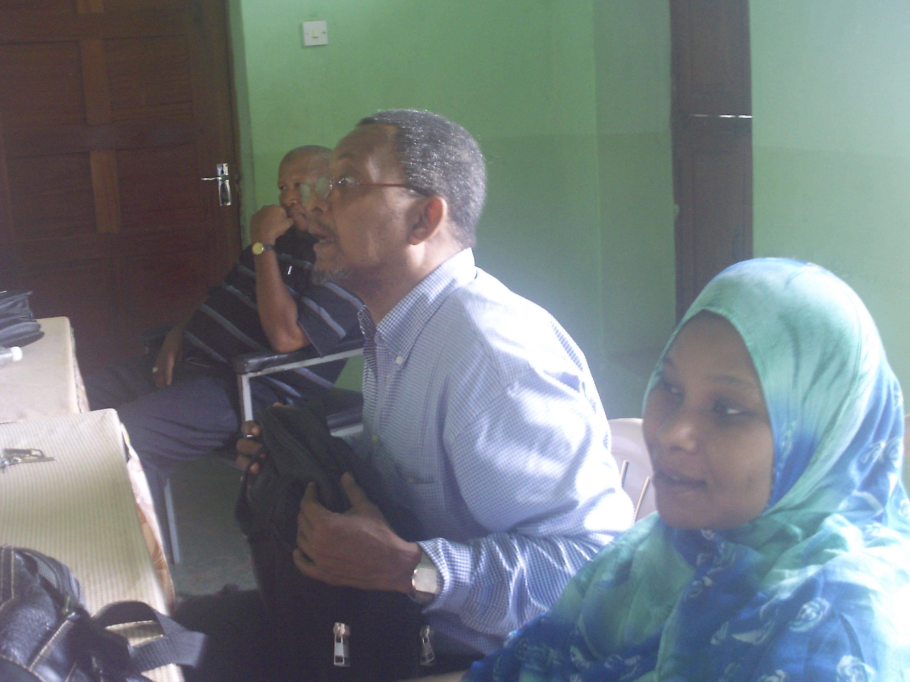
CODECOZ chairperson Mr Hamza Rijaal insisting the points during the opening of the meeting

PRESENTATION AND DISCUSSIO OF TOSA FINDINGS
The facilitator, Mr Rashid Moh’d presented the report on TOSA findings.
Then participants aired their views and comments on the findings. Among the comments delivered the following are the highlights:-

- There are some topographical errors that must be corrected.

- Finding opportunities for NGOs from the Government institutions do or do not exist. This should be checked and details included in the report.

- The graph showing key categories assessed and scores per category should be in improved.

- Founder members of the Organisation should appear in Annex of the report.

- Limitations include absence of beneficiaries.

- Major challenges to include lack of strategies for policy formulation and implementation.

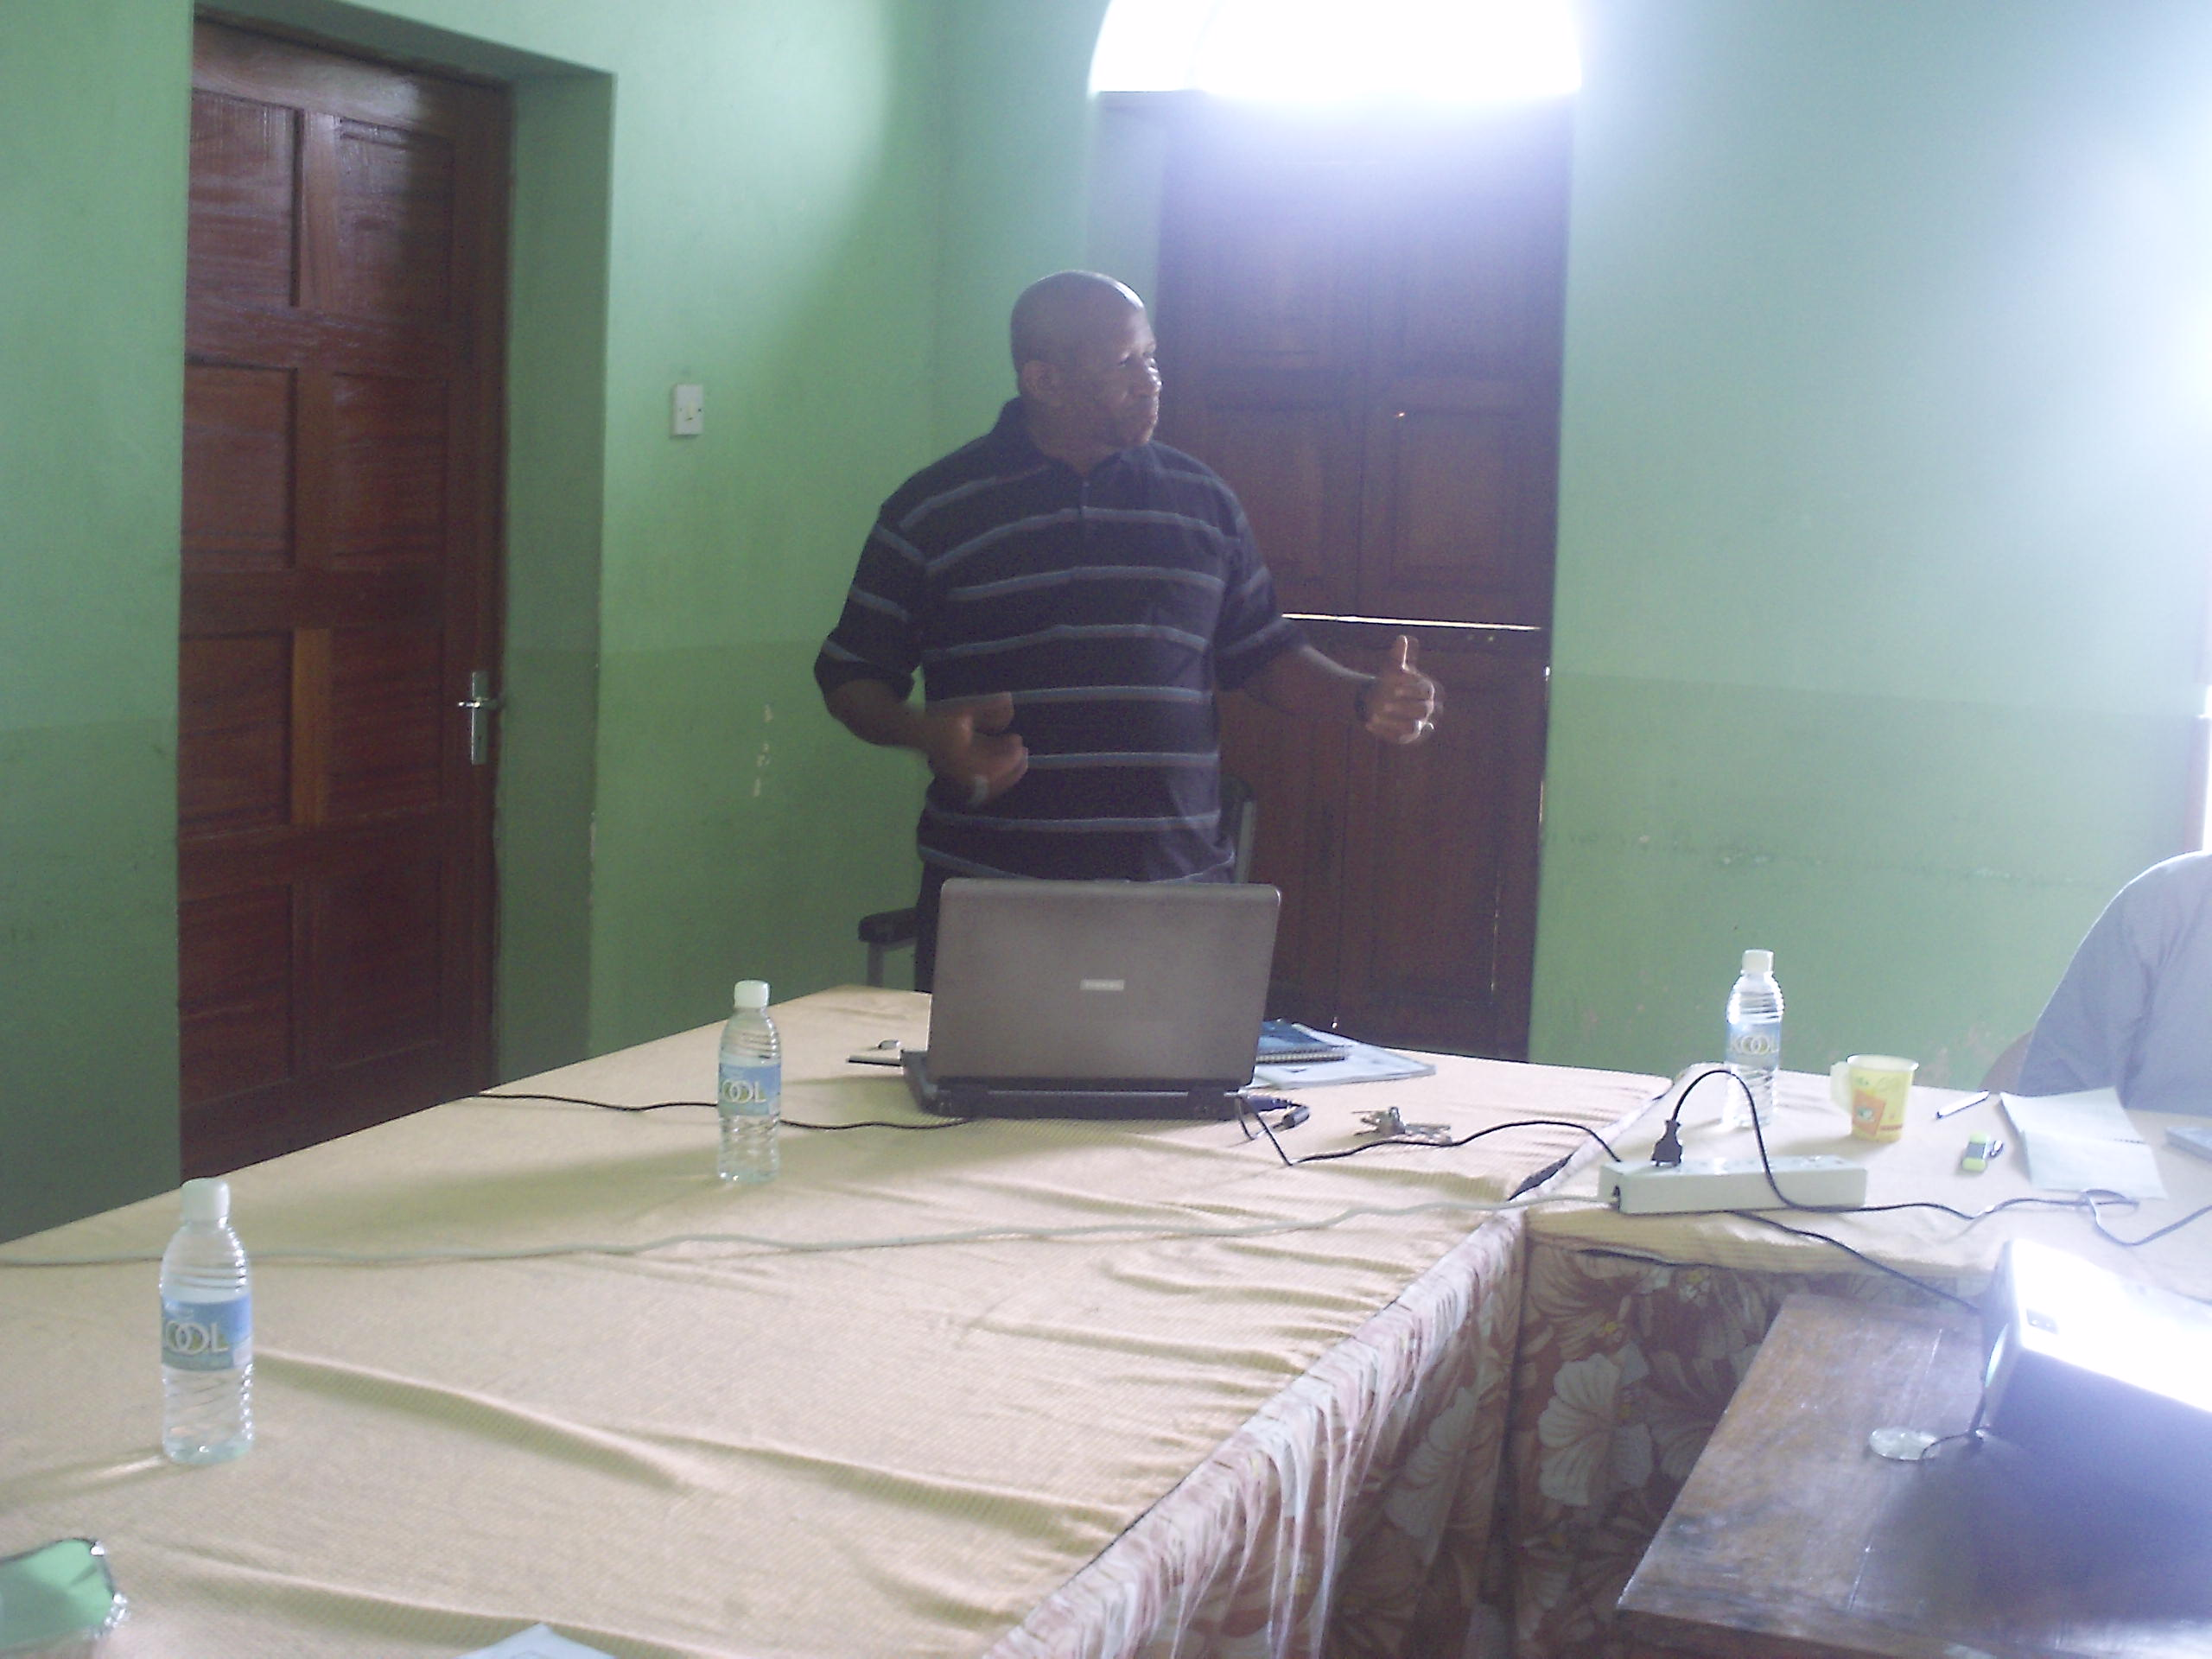
The facilitator Mr. Rashid while presenting the report/findings (TOSA)

The facilitator promised to incorporate the suggestions for improvement of the report and later submit the final report to the Executive Secretary CODECOZ.

CODECOZ Chairperson then requested participants to give other comments regarding environmental issues in the country. He sited environmental problems that are encountered at the moment being:-

- Electronic and Electrical wastes (E Wastes)

- Plastic bags
- Electrical saw
These are advocacy issues

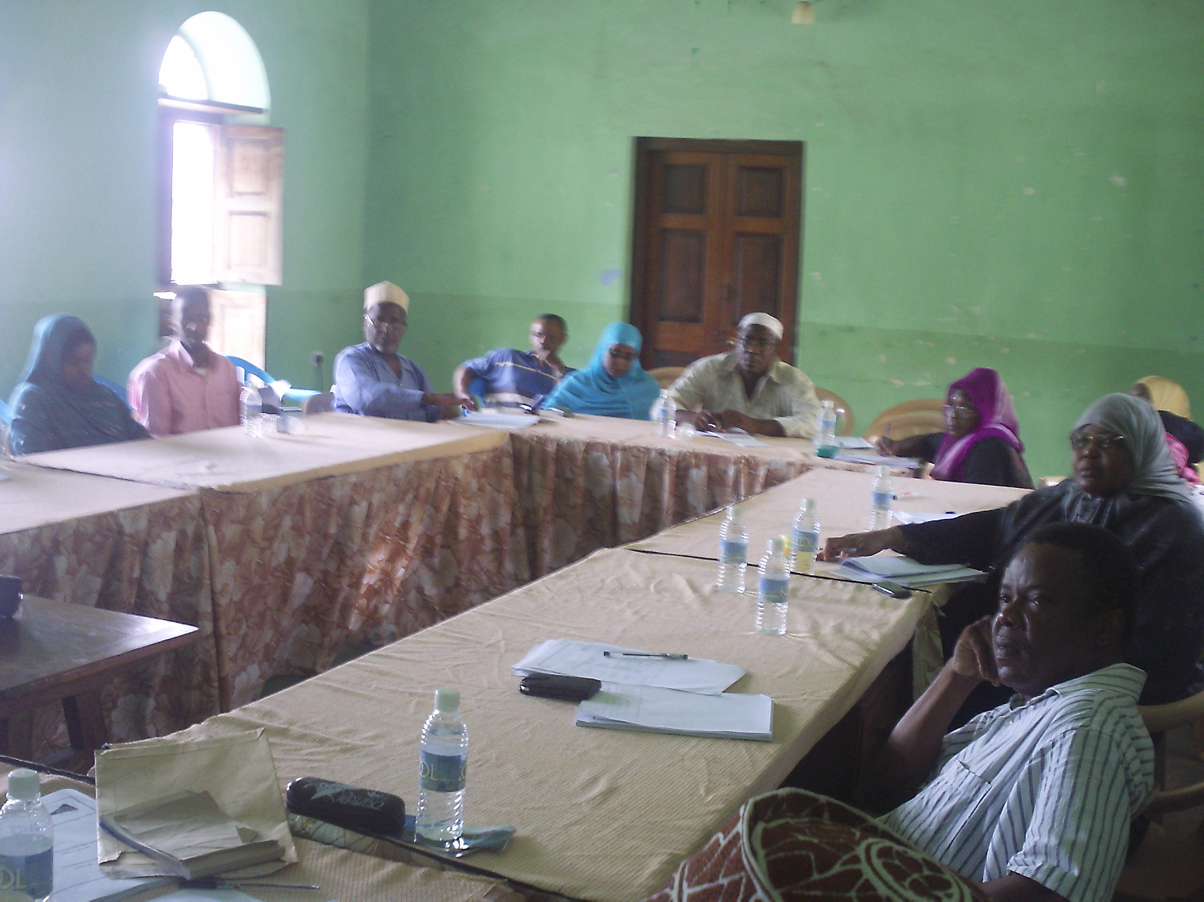
Participants listening attentively to the presentation on OCA findings.

- Reviving MTAMAZA – General comments on the above mentioned burning issue includes:-
- Need of environmental education programme for raising awareness of those involved and the public in general the network should be legally registered to enable it to operate fully such as dealing with climate change and other global environmental initiatives.

- Finding networking opportunities with Global and Regional Environmental bodies which might increase the funding sources for CODECOZ.

- The responsibilities of the Board of Trustees include fundraising. There for board members should seek funding opportunities for CODECOZ for its future programmes.

PRESENTATION AND DISCUSSION I ON INTRODUCTION TO RESOURCE MOBILISATION.

The presentation started t 11:15 am by the facilitator introducing the topic and saying that it is a long presentation that needs at last 3 days. However, he managed to highlight the subtopics and gave brief explanation on each so that participants could get the idea on the issues discussed.

The subtopics explained include:-

- Definition

- Resource Mobilisation and Fundraising

- Purpose of fundraising

- Requirements of the Organisation

Developing Resource Mobilisation strategy (steps)

- Definition of fundraising

- Different ways of fundraising

- Challenges of fundraising

- Effective approaches for fundraising

- Limitation to Fundraising

PARTICIPANTS COMMENTS

- Full training on resource mobilisation should be organised by CODECOZ.

- We need to develop resource mobilisation strategy for our organisation

- After strategic planning workshop we need to sit down and discuss on how we shall acquire needed resources for our organisation.

FACILITATOR’S REMARKS
The facilitator winded up the presentation by responding to few remarks of the participants. He then thanked all for their active contribution and expressed his hope for CODECOZ capacity improvements and better performance in its future undertakings.

CLOSING
DR Salim, a member of Board of Trustees who works with the Institute of Marine Sciences officiated closing the meeting.

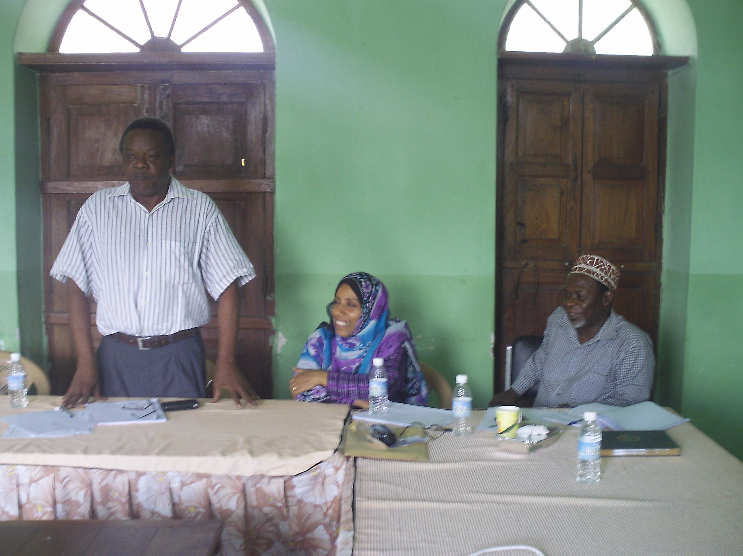
Dr. Salum M. Mohammed while closing the meeting

In his closing remarks he thanked all participants for their contribution in the discussion of the self assessment report. Commenting on resource mobilisation presentation he said that for him it was an eye opener and emphasised on the need for a full training of leaders and members on the subject. He called for more efforts from members and the organisation in ensuring that Zanzibar environment is protected and conserved. He closed the meeting at 14: 45 pm

Prepared by
- Capt Hamza M. Omar
- Mwanakhamis K Soud

List of Participants

N/No | Names | Position
 | Hamza Z Rijaal | Chairperson
 | Asha M Juma | Member
 | Judama S Khamis | Member
 | Dhulfa H Ali | Member
 | Hassan H Hassan | Not Member
 | Fatma S Khamis | Member
 | Mwanamvua M Hassan | Member
 | Dr.Narriman S Jiddawi | Board Member
 | Mwanakhamis K Soud | Member
 | Dr.Salim M Mohammed | Board Member
 | Salma S Abdallah | Member
 | Capt. Hamza M Omar | Secretary
 | Hamad O Juma | Member
 | Moh’d Kh Mwanvura | Member
 | Salim Kh Said | Member
 | Mgeni H Salum | Admin Assistant
 | Amoun U Mdowe | Member
 | Juma B Alawi | Member
 | Mohammed A Masoud | Member

